Youth employment and entrepreneurship in agri-food systems: a framework for interventions
April 2019

Background
On many continents, young women and men represent a promising, yet untapped, source of opportunities for disruptive innovation for transforming food systems. Youth, defined as between the ages of 18-35, particularly in low and middle-income countries and especially in rural areas, struggle to make the transition from education to work, find decent jobs or earn a living, and become financially independent. A growing aspiration gap lays bare the friction between economic realities and what it means for them to be decently employed or a successful entrepreneur.
Agriculture or related sectors will likely continue to be the dominant sector, providing employment for a majority of young women and men over the next few decades (OECD 2018, Badiane et al. 2018). Fortunately, the high demand for agricultural products; fresh and processed, nationally, regionally and globally creates good opportunities for job and wealth creation. Given the population and income growth taking place, expansion in urban markets across the continent, the significant amount of money spent on imported food, not to mention the immense productive potential for agriculture in Africa, it is evident that there are significant opportunities for Africa (Badiane et al., 2018) whose young population is expected to double to 830 million by 2050.
Developing sustainable agri-businesses can motivate young women and men to create new jobs or to earn incomes. Hence, transformative change for youth employment and entrepreneurship in agri-food systems must be linked to achieving SDG 2 (zero hunger), SDG 1 (poverty alleviation), SDG 5 (gender equality), SDG 8 (decent work and economic growth), SDG 9 (industry, innovation and infrastructure) and SDG 17 (partnerships). This would have to be promoted in both formal and informal sectors as both are a reality and part of the sustainable food systems.

Why a brief on youth employment and entrepreneurship?
Increasingly, national and global organisations are recognising the urgency of addressing the matter of youth employment and entrepreneurship. Various influential institutions have defined their commitment to this cause. To name a few:
- The G20 has pledged to support the African Union to double the total productivity and increase youth employment by 30% in the agricultural sector by 2030.
- The European Commission is proposing a new 'Africa – Europe Alliance for Sustainable Investment and Jobs' to substantially boost investment in Africa, strengthen trade, create jobs, and invest in education and skills. Investment through the Alliance will create up to 10 million jobs in Africa in the next 5 years and 750,000 people will receive vocational training for skills development.
- The Jobs for Youth in Africa strategy of the African Development Bank aims to create 25 million jobs and equip 50 million youth by 2025.
Despite the good intentions, earlier approaches have yielded varying results. Yet the ambitions to address youth employment and entrepreneurship are not trivial. Therefore, the question is whether present and future interventions will lead us to achieve these ambitious goals.
While youth employment and entrepreneurship creation is a complex problem, and to date hardly any research has been conducted as to which strategies could be most impactful and in which context, many organisations have started rolling out activities that are addressing one main issue or a few issues. These programmes may not reach full potential if many of the other underlying causes for un/underemployment and unsuccessful entrepreneurship are not tackled. It is hoped that this framework (which is still work in progress) would help inform decisions as to the area in which to intervene for investments to have greatest impact on decent employment and entrepreneurship for young women and men, and which partnerships should be fostered for a more comprehensive and coherent approach to reach more young people and have greater impact.
The framework analysis
According to the OECD the majority of young people in developing countries are self-employed. They are sometimes referred to as entrepreneurs, but in reality only a tiny portion of young entrepreneurs prove to be successful, whether in terms of earnings, profits or job creation. Most youth businesses remain in subsistence activities. The greatest challenge is that youth in many developing countries are oftentimes held back by low levels of education, high levels of informality, poor or inadequate physical infrastructure and limited access to finance. They choose to be self-employed for lack of better options. Young women entrepreneurs tend to be even more disadvantaged than men (OECD, 2017).
According to Dekker and Hollander (2017) only 15% of jobs in African countries are in formal wage labour. At the same time, there are complaints of the private sector that they cannot find qualified employees because educated young women and men do not necessarily meet labour market needs (AfDB et al., 2017).
Hence many interventions are based on the assumption that young people are either insufficiently equipped or not sufficiently motivated to support the agricultural transformation agenda. Numerous education, skills training, behavioural change for activation, mentorship, incubator and entrepreneurship programs are being developed and implemented. These programs suggest that markets do (or would) hold sufficient opportunities and empowering young people would suffice to enable them to enter these markets. A USAID evaluation of youth employment programmes in low-income countries called these interventions a PUSH strategy because organisations pro-actively offer these ‘solutions’ (Fox and Kaul, 2017). This has been captured in orange in the figure below.
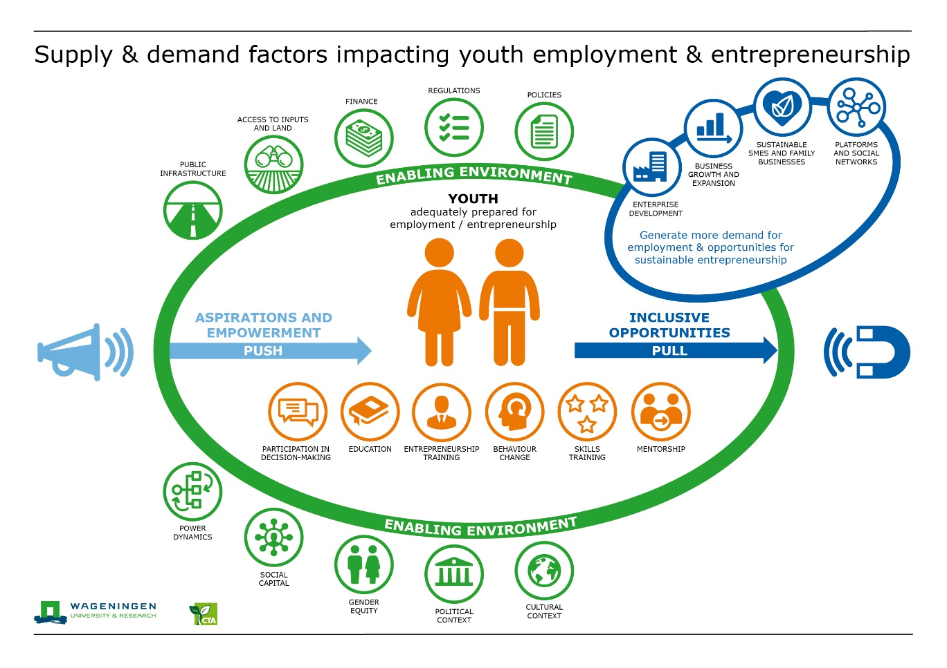
Draft version, subject to revision
The enabling environment
The same report concluded that while youth entering the labour force are becoming more educated, the lack of private investment is limiting their opportunities suggesting that there are other factors hampering their successful engagement in the economy. Because these economic activities are influenced by a context-specific enabling environment the experiences of the Market Systems Development (MSD) approach was considered to see if it could help shed some light on other factors influencing decent employment creation and/or the conditions for achieving greater success in entrepreneurship (green in the figure).
The MSD approach recognises that the development of inclusive systems for stimulating growth and expanding access, means transforming the market systems around them. It provides a coherent, rigorous approach to understanding and intervening in markets so that they function more efficiently and sustainably for the poor. The market system is a multi-function, multi-stakeholder arrangement comprising the core function of exchange by which goods and services are delivered and the supporting functions and rules are performed and shaped by a variety of players. Decent job creation and creation of successful entrepreneurship opportunities for young women and men take place within these market systems.
While there are factors (such as public infrastructure, costs of inputs, and policies) that affect everyone in the market system there are also obstacles that tend to have a proportionately different impact on young women and men. Obvious examples are access to land, access to finance and access to information that could help raise productivity and growth of businesses. To improve access to such inputs for young people would require new policies or specific policy measures, and innovative interventions and solutions.
Gender inequality is an important barrier. Understanding how and why systems serve young women and men differently has to be part of rigorous analysis, informing the ability of partners to design programmes and work towards a sustainable vision of systems that benefits both. Young women and young men need basically the same support mechanisms but the absence of inadequate resources will impact each gender differently. In the same vein, rural youth face age-specific vulnerabilities which their counterparts in urban areas do not encounter or do but to a lesser extent. They may suffer from limited opportunities to receive quality education and vocational training, and a lack of voice in decision-making.
Less obvious factors may be the impact of family and social norms, or the influence of a cultural context on both youth aspirations for the future and their actual agency when pursuing work and entrepreneurial opportunities and navigating uncertainty. Organisations must be careful in designing interventions as the ‘Western concept of entrepreneurship’ may not be appropriate for all local contexts.
It is therefore imperative that organisations (facilitators) engage young women and men in the conceptualisation and evaluation of their proposed interventions as well as in the implementation of programmes. It is an important part of ensuring that needs and aspirations of youth are taken into account. Beyond questioning individualistic, demand and supply oriented approaches from an economic viewpoint, it is also important to look at how young people are embedded in social relationships and societal norms. They are in the best position to inform strategies on how to achieve youth employment and youth entrepreneurship. This is the reason why young women and men are centrally positioned in the figure and why the pull side includes communication channels such as ‘platforms and social networks’ that are often used by youth.
Agri-food systems transformation
Through the MSD approach it is easier to see the potential (positive or negative) impact of context specific elements in the enabling environment on the creation of youth employment and entrepreneurship opportunities within the current market system. However, it may not provide all the insights needed when designing strategies for the role of young women and men in the transformation of the agricultural sector or the broader agri-food system.
As the USAID evaluation concluded, employment opportunities in low-income countries reflect the pace of economic and structural transformation, including the number and size of modern enterprises in response to consumer demand. Therefore, according to the evaluators, it may be time for a fundamental reassessment of approaches for addressing youth employment and the youth transition in low-income countries. In designing strategies, policies, and programs to meet the entry-into-employment or self-employment challenge for youth, the starting point is to diagnose the economy and current/future employment opportunities (Fox and Kaul, 2017).
The influx of labour without adequate preparation for absorbing and optimising technical changes will depress labour productivity and incomes. Agriculture and the agri-food industry, especially in developing countries must therefore transform if young people are to actively participate and contribute to achieving SDG2. In environments where market conditions do not offer opportunities, entrepreneurialism does not resolve either the un- or the under-employment problem and instead merely makes young people ‘entrepreneurially underemployed’. Skilled people with capacities in an environment that is not enabling viable employment and/or entrepreneurship opportunities will most likely not solve the problem. On the contrary, it may cause more frustration among the youth who are well prepared but unable to reach their ambitions through their own efforts. Facilitating the transformation of the agri-food system in such a way that decent employment and entrepreneurial opportunities are generated and thereby creating demand and attracting the youth who are themselves responsive and receptive to innovation, is what we call the PULL strategy in the figure (blue).
A more vibrant, sustainable and inclusive agri-food system (production, processing, marketing, trade, etc.) may well be a sustainable solution for employment. Moreover, new ‘green’ industrialisation strategies could leverage more creative forms of entrepreneurship in the pursuit of sustainable and resilient food systems. This could hold considerable job-creation potential for young people.
As agro-food systems transition, jobs can be created in rural and urban areas in developing countries. Turning this potential into real jobs would require substantial new investment in modernising national and regional food systems – from regulatory mechanisms to infrastructure to improved production, processing and packaging and access to markets. Food processing is particularly relevant because agro-industries are more likely to locate themselves in small towns and rural areas closer to major production sites and where road and telecommunication networks are available (OECD, 2018). To improve trade performance, action is needed to raise productivity along the value chain, reduce trade costs, and eliminate barriers to trade. Significant incremental growth can be achieved by improving the productivity of both land and labour without displacing labour. Local producers can capture thriving domestic and regional markets if they become more competitive. Measures that reduce the costs of production (such as access to improved technology) and the costs of marketing (such as investment in transportation and infrastructure) will enable increased profitability and reduce food costs (Brooks et al. 2013).
Africa’s growing population is becoming richer and more urban, leading to changes in the composition of diets and stronger demand for higher-value and processed food products. This presents valuable opportunities for African farmers, processors, and other value chain actors, as well as potential for increased intra-regional trade (Badiane et al., 2018). According to the AfDB et al. (2017) new industrialisation strategies should target the continent’s fast-growing private enterprises which have potential to create quality jobs. Strategies should include high-potential entrepreneurs. Start-ups and small and medium-sized firms with high-potential can complement the growth of large companies in driving Africa’s industrialisation.
Despite all these encouraging signs, Fox and Kaul (2017) conclude that in the near future there will still be more labour supplied than wage jobs in most countries as new enterprises take time to get started. For that reason, an employment strategy should also feature support for transforming the informal sector (agricultural and non-agricultural sectors), especially in countries where the labour force is growing rapidly.
The food systems approach (van Berkum et al., 2018) may be useful to decide on the most appropriate pathways for agri-food system transformation, including the trade-offs between intervention strategies, in tackling the challenges of youth employment and entrepreneurship from a structural transformation (PULL) strategy.
A living framework
In the framework an attempt has been made to capture the friction between youths being adequately prepared and able to obtain decent employment or become successful entrepreneurs, and the limited opportunities and other constraints that currently exist and need to be tackled to effectively transform the agri-food system. The framework also shows that these processes take place within an environment that can enable or hinder job and wealth creation and entrepreneurship.
While the framework shows a complex interplay of interacting subsystems that impact on job creation and entrepreneurship in a specific setting and time, coming to grips with the mechanisms that play a key role in the interaction and on their interdependencies is challenging. Each circle represents a ‘big box’ that still needs to be unpacked. Nevertheless, it is hoped that the framework does create awareness that activities are never carried out in isolation, that it gives structure to the context analysis, that an intervention that is undertaken in a context where other elements are not conducive will have limited impact, that it helps shed light on potential pathways to create more opportunities for success in addressing youth employment and entrepreneurship, and that it gives insights in potentially useful partnerships to increase joint impact..
Youth themselves as well as governments, development partners, financial institutions, private investors, other community members, and academic and training institutions are seen as essential partners. This partnership (SDG 17) is needed in order to follow the holistic approach that will be required to achieve the targets. Focussing on only one or a few elements of the diagram will not sufficiently address the urgent matter of youth employment and entrepreneurship in agri-food systems transformation. Stakeholders are encouraged to actively look for partners who are already working on or could have a positive impact on other aspects.

Key messages
- Work with & through youth networks. Put youth at the centre as they are the key to agri-food systems transformation, given their interest and ability to learn and adopt, use and adapt technology.
- Impact at scale requires working in partnership at multiple levels and through different pathways. Therefore actively build synergies with partners that both specifically target youth as well as aim to mainstream them within broader strategies.
- Opportunities for youth employment and entrepreneurship will only meaningfully improve through transformation of food systems themselves. Investments in both must go hand-in-hand so that agri-food sector becomes more developed and decent work is created.

Conclusion
Wageningen University & Research is currently testing the framework in three agri-food sector transformation programmes in Sub Saharan Africa. The Technical Centre for Agricultural and Rural Cooperation (CTA) is implementing actions to foster sustainable youth employment in Kenya and other countries in Sub Saharan Africa by building youth entrepreneurial and information and communication technology capacity in priority value chains and providing grants to scale-up their operations. New insights from WUR and CTA will be included in a new/updated figure of the framework.
We would love to hear from you whether the framework captures the multiple issues and addresses the most effective ways to overcome the challenge of youth under- and unemployment, and expand youth entrepreneurial opportunities. Can it help guide meaningful interventions? Which suggestions do you have for improvements? We are looking forward to a journey of continued learning and improved capacities.

References:
African Development Bank, Organisation for Economic Co-operation and Development, United Nations Development Programme (2017). African Economic Outlook 2017: Entrepreneurship and Industrialisation. http://dx.doi.org/10.1787/aeo-2017-en
Badiane, Ousmane, Odjo, Sunday, and Collins, Julia (Eds). 2018. Africa Agriculture Trade Monitor Report 2018. Washington, DC: International Food Policy Research Institute (IFPRI). https://doi.org/10.2499/9780896293496
Brooks, Karen; Zorya, Sergiy; and Gautam, Amy. 2013. Employment in agriculture: Jobs for Africa’s youth. In 2012 Global Food Policy Report Chapter 5. Pp. 48-57. Washington, D.C.: International Food Policy Research Institute. http://ebrary.ifpri.org/cdm/ref/collection/p15738coll2/id/127434
Marleen Dekker and Saskia Hollander. 2017. Boosting youth employment in Africa: what works and why? https://includeplatform.net/wp-content/uploads/2017/07/FullConferenceReport.pdf
Louise Fox and Upaasna Kaul. 2017. The evidence is in: How should youth employment programs in low-income countries be designed? https://doi.org/10.13140/RG.2.2.22191.84649
OECD (2017), Unlocking the Potential of Youth Entrepreneurship in Developing Countries: From Subsistence to Performance, OECD Publishing, Paris. https://dx.doi.org/10.1787/9789264277830-1-en
OECD (2018), Development Co-operation Report 2018: Joining Forces to Leave No One Behind, OECD Publishing, Paris. https://doi.org/10.1787/dcr-2018-en
Van Berkum, S; J. Dengerink and R. Ruben. 2018. The food systems approach: sustainable solutions for a sufficient supply of healthy food. Wageningen Economic Research. https://doi.org/10.18174/451505

Contact Persons:
Wageningen University and Research: jennie.vandermheen@wur.nl; thomas.tichar@wur.nl
The Technical Centre for Agricultural and Rural Cooperation: francis@cta.int; lohento@cta.int

International organisations such as the UN, the OECD and others, as well as national governments, use varying definitions of ‘youth’ or ‘young people’. Most UN bodies (including the ILO and the United Nations Educational, Scientific and Cultural Organization – UNESCO) define youth and young people as anyone between the ages of 15 and 24; this is also the definition used for official UN statistics. Sometimes a ‘life cycle approach’ is used, focussing on the school-to-work transition to define youth. For the purpose of this brief, youth is defined as between ages 18 and 35.
According to the International Labour Organization (ILO), decent work involves opportunities for work that are productive and deliver a fair income, security in the workplace and social protection for families, better prospects for personal development and social integration, freedom for people to express their concerns, organize and participate in the decisions that affect their lives and equality of opportunity and treatment for all women and men.
Unemployment / underemployment – The AfDB suggests to use the NEET rate of youth, which is the rate of youth ‘not in employment, education or training’. In poorer regions of the world, however, the problem is not so much youth unemployment as it is underemployment. AfDB describes underemployment with reference to the term ‘vulnerable employment’, which fundamentally denotes ‘workers in unprotected forms of employment, with low productivity and high risk of poverty’.
Informal sector / entrepreneurship: This is an important type of employment for many young people. It involves to a large extent agriculture and is often considered as ‘entrepreneurship’. According to the AfDB, many people in developing countries undertake self-employment because they have no other choice. Sometimes this is referred to as ‘necessity or survival’ entrepreneurship.
According to the AfDB, the share of Africans living in urban areas is estimated to grow by 70% by 2050.
According to the AfDB, Africa’s food import bill is expected to increase to over US$ 110 billion by 2025. According to IFPRI the demand for imported food is growing faster than the supply of domestically produced substitutes.
Africa’s structural transformation: the growth in incomes and resulting diversification of the economy

