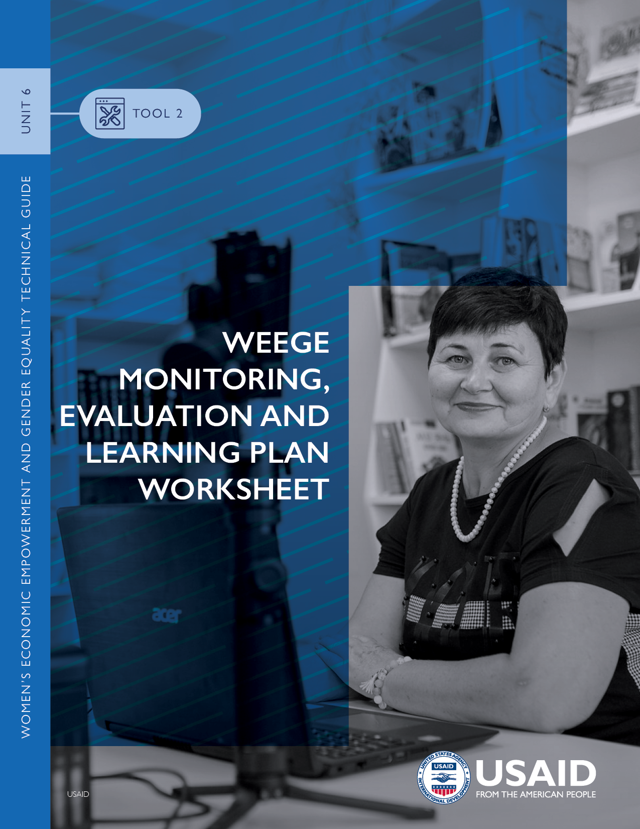



This worksheet serves as a reference when incorporating women’s economic empowerment and gender equality (WEEGE) into a monitoring, evaluation and learning (MEL) plan. It can help to identify areas where additional WEEGE work can be done, and to coordinate efforts around WEEGE MEL.

# OVERVIEW

Each of the following tables is structured around the results framework and reflects the different levels of WEEGE MEL: strategy-, project- and activity-level planning. The tables can be customized as needed. To begin, ask the two framing questions below, which provide the foundation for analysis of WEEGE indicators and MEL planning. Add the answers to the tables that follow.

## Question I:

* At the country development cooperation strategy (CDCS) level, does the results framework have a development objective (DO) that is specific for WEEGE (yes/no)? If yes, what is it?

## Question 2:

* A person posing for a picture

  Description automatically generated with low confidenceAre there intermediate results (IRs) and sub-IRs that are specific to WEEGE under any DO, whether or not the DO includes WEEGE (yes/no)? If yes, what are they and under which DO do they belong?

Table 1. CDCS- and Project-Level WEEGE Indicator Details

|  |  |  |  |  |  |
| --- | --- | --- | --- | --- | --- |
| DO [#]: [INSERT DO DESCRIPTION] | | | | | |
| **PROPOSED VERSIONS** | | | | | |
| PROPOSED NEW IRS AND SUB-IRS THAT FOCUS ON WEEGE | PROPOSED NEW WEEGE INDICATORS | SOURCE | METHODOLOGY | FREQUENCY OF COLLECTION | LEVEL (NATIONAL, SUBNATIONAL, HOUSEHOLD, OR INDIVIDUAL) |
| IR [#] |  |  |  |  |  |
|  |  |  |  |  |
| Sub-IR [#.1] |  |  |  |  |  |
|  |  |  |  |  |
| Sub-IR [#.2] |  |  |  |  |  |
|  |  |  |  |  |

This worksheet outlines existing and new WEEGE-specific DOs and related IRs, sub-IRs and indicators. (Select this link for [Tool 1: WEEGE Illustrative Indicators](https://www.marketlinks.org/weege-wiki/693-tool-1-weege-illustrative-indicators).) It encourages people involved in mission MEL planning to consider the linkages between the DO, IRs, sub-IRs, indicators and associated [activities](https://usaidlearninglab.org/sites/default/files/resource/files/cleared_-_how-to_note_-_activity_mel_plan_sep2017.pdf). Use a separate table for each DO, if necessary.

|  |  |  |  |  |  |
| --- | --- | --- | --- | --- | --- |
| DO [#]: [INSERT DO DESCRIPTION] | | | | | |
| **CURRENT VERSIONS** | | | | | |
| EXISTING IRS AND SUB-IRS THAT FOCUS ON WEEGE | EXISTING WEEGE INDICATORS | SOURCE | METHODOLOGY | FREQUENCY OF COLLECTION | LEVEL (NATIONAL, SUBNATIONAL, HOUSEHOLD, OR INDIVIDUAL) |
| IR [#] |  |  |  |  |  |
|  |  |  |  |  |
| Sub-IR [#.1] |  |  |  |  |  |
|  |  |  |  |  |
| Sub-IR [#.2] |  |  |  |  |  |
|  |  |  |  |  |

Table 2. Activity-Level WEEGE Indicator Details

Typically, the implementing partner writes and maintains the activity’s MEL plan (select this link for an [Activity “How-To Note](https://usaidlearninglab.org/sites/default/files/resource/files/cleared_-_how-to_note_-_activity_mel_plan_sep2017.pdf)”); the contract officer’s representative (COR) or agreement officer’s representative (AOR) reviews, comments on and approves it. MEL specialists, CORs, and AORs should advise on the inclusion of gender-sensitive and WEEGE-specific indicators in activity MEL plans and should provide [Tool 1: WEEGE Illustrative Indicators](https://www.marketlinks.org/weege-wiki/693-tool-1-weege-illustrative-indicators) to implementing partners. Discussing potential WEEGE activity-level indicators together with partners, immediately after award, is an important first step to ensuring alignment of WEEGE-related indicators from the CDCS with the activity.

When completing Table 2, it may be helpful to insert an implementing partner’s indicator tracking table or transcribe relevant information. By compiling all information into this table, it may be easier to track the overall WEEGE indicators in Table 3.

|  |  |  |  |
| --- | --- | --- | --- |
| ACTIVITY NAME: | | | |
| **GEOGRAPHIC LOCATION:** | | | |
| ACTIVITY LEVEL OF IMPLEMENTATION [SUCH AS NATIONAL, SUB-NATIONAL, HOUSEHOLD OR INDIVIDUAL] | | | |
|  | Indicators | Source, Methodology, Frequency of Collection | Indicator Level (national, sub-national, household or individual) |
| IR [#] |  |  |  |
|  |  |  |
|  |  |  |
| Sub-IR [#.1] |  |  |  |
|  |  |  |
|  |  |  |  |

Table 3. Mapping WEEGE Indicators at All Levels

|  |  |  |  |
| --- | --- | --- | --- |
| ACTIVITY NAME: | | | |
| **GEOGRAPHIC LOCATION:** | | | |
|  | STRATEGY (CDCS) LEVEL | PROJECT LEVEL | ACTIVITY LEVEL |
| WEEGE-related DOs |  |  |  |
|  |  |  |
|  |  |  |
| WEEGE-related IRs and sub-IRs |  |  |  |
|  |  |  |
|  |  |  |
|  |  |  |  |
| WEEGE-related indicators |  |  |  |
|  |  |  |  |

This table is useful for developing an overall picture of WEEGE in the MEL process. It encourages thinking around the interconnectedness of WEEGE and ensures consistency between information needed at the strategy, project and activity levels.