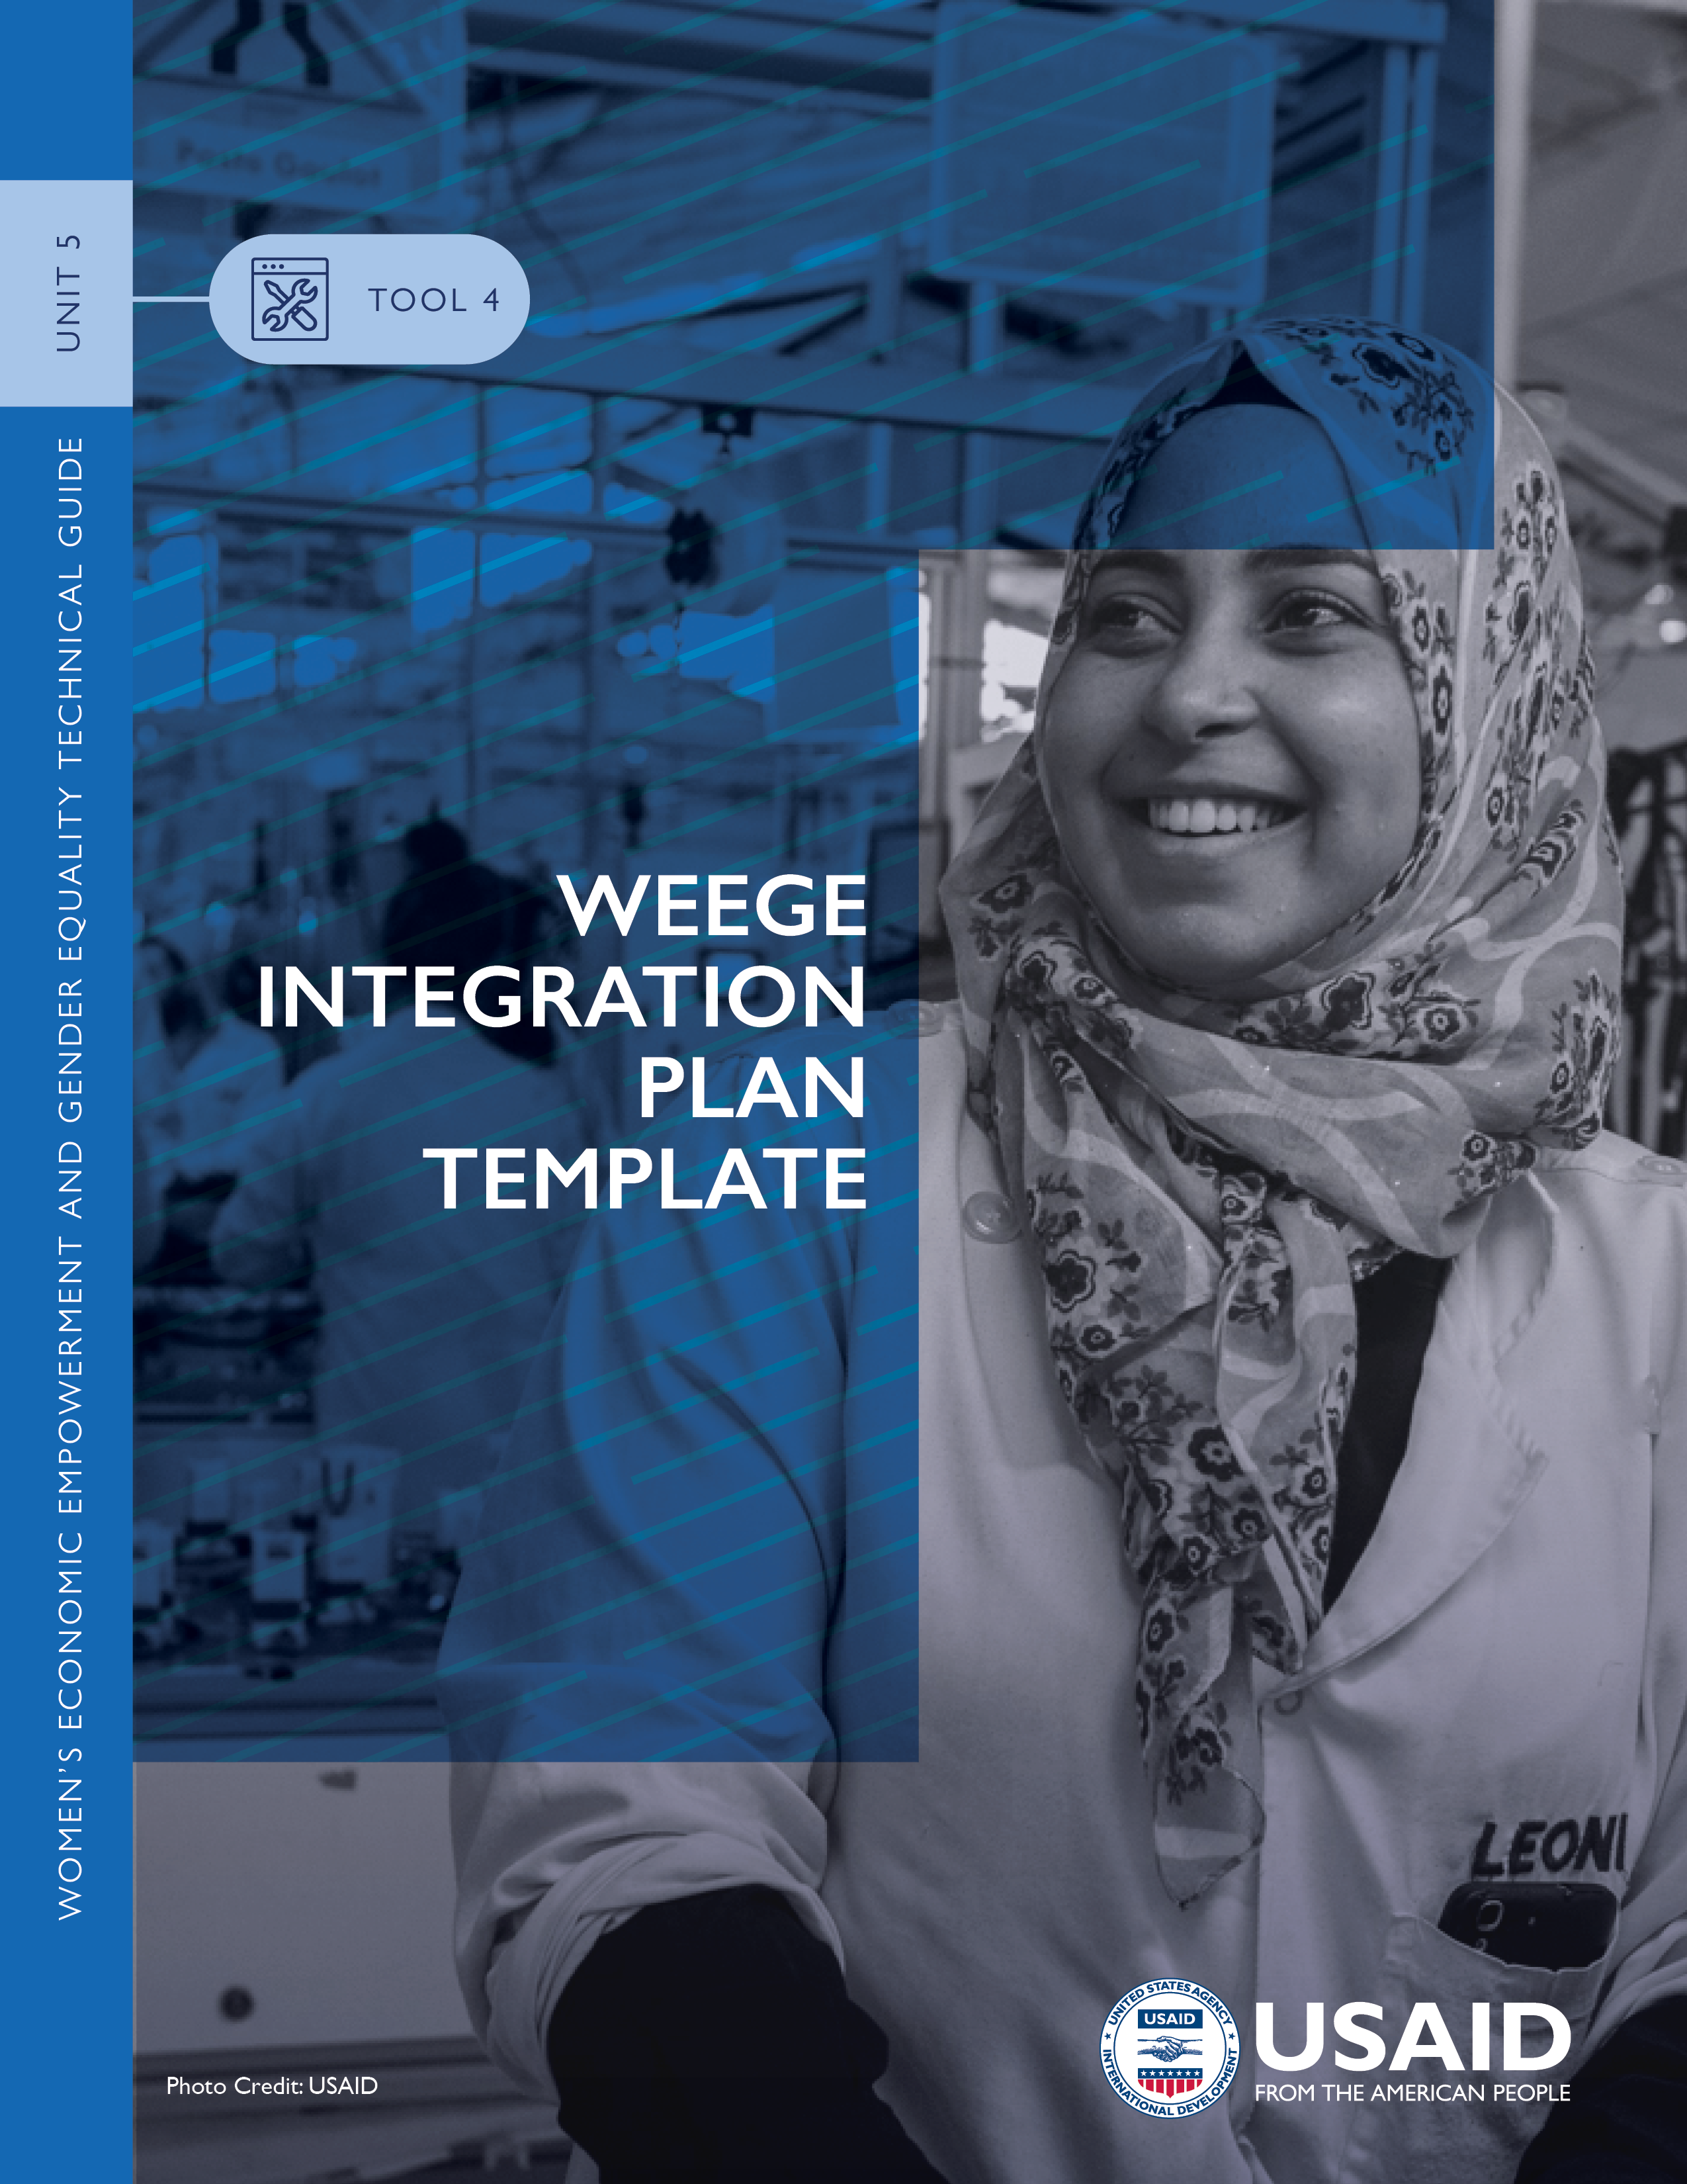

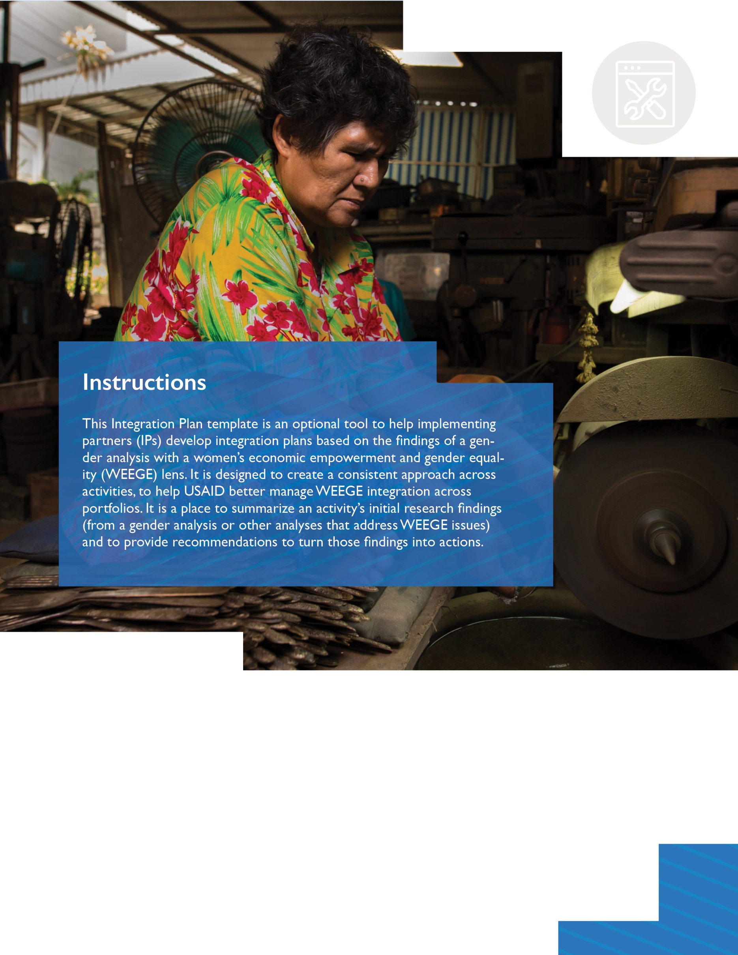

When using this template, delete all instructions [shown in brackets] and replace all headings and text with your own content. Please note that this template is based on the USAID Graphic Standards Manual and Partner Co-Branding Guide revised in February 2020. To ensure that the plan adheres to the most recent information and templates, visit https://www.usaid.gov/branding/. Please also refer to the ADS Style and Format Guide, a Mandatory Reference for ADS Chapter 501.

The template starts on the next page.

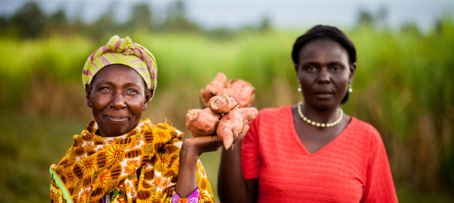

Photo Credit: [Name]

ACTIVITY TITLE GOES HERE
[EXAMPLE: WOMEN’S ECONOMIC EMPOWERMENT AND EQUALITY TECHNICAL ASSISTANCE TASK ORDER]
REPORT TITLE GOES HERE
[EXAMPLE: WEEGE INTEGRATION PLAN]
Optional Subtitle Can Go Here
[INSTRUCTIONS: DELETE THIS BOX IN FINAL TEMPLATE]

The title should be informative, with no acronyms and no implementing partner names.
[Change the cover photo to one that is relevant to the context, and update photo credit accordingly. To change a placeholder photo: 1. Right-click placeholder photo, 2. Select “Change Photo”, 3. Choose “From a File”, 4. Select desired photo from computer, 5. Click “Insert”]

ACTIVITY NAME
REPORT TITLE
Optional Subtitle

[MONTH DAY, YEAR]
PROJECT NUMBER: [INSERT NUMBER, IF ONE EXISTS]

FUNDING MECHANISM NUMBER [INSERT NUMBER]
SUBMITTED TO: [ENTER NAMES AND TITLES]

DEVELOPMENT EXPERIENCE CLEARINGHOUSE CATALOGUE NUMBER [IF REQUESTED IN ADVANCE OF PUBLICATION]

DISCLAIMER [if report is not authored by USAID]
This document was produced for review by the United States Agency for International Development. It was prepared by [organization] for [project/activity name]. The author’s views expressed in this publication do not necessarily reflect the views of the United States Agency for International Development or the United States Government.

TABLE OF CONTENTS

TABLE OF FIGURES / LIST OF TABLES iii
ACKNOWLEDGMENTS iv
ACRONYMS v
KEY TERMS AND DEFINITIONS vi
BACKGROUND AND CONTEXT 1
APPROACH 2
EXAMPLE 2
OBJECTIVES 3
EXAMPLES 3
ANALYSES WITH A WEEGE LENS 3
FINDINGS 3
RECOMMENDATIONS 3
CONCLUSIONS 4
ANNEXES 5
ANNEX A: ILLUSTRATIVE INTEGRATION CHECKLIST 6
ANNEX B: ILLUSTRATIVE SUB-ACTIVITIES FOR ACTIVITY WORK PLAN 8

[Update the table of contents when you finalize the report: Select the text that says Table of Contents. A blue box should appear, select the arrow in the blue box at top left and select “update table.” Alternatively, right click on the table and then select “update field.”]

TABLE OF FIGURES / LIST OF TABLES
[Update the table based on figures, boxes, or tables used in the report. To allow for a table of figures to pull from the document, insert a caption on any figure, table, or box. Right click on the respected item in the document you wish to label and then select “insert caption.” Then label the item accordingly. Make sure the caption still follows USAID style in fonts and size.]

TABLE 1. EXAMPLE TABLE 1
TABLE 2. ILLUSTRATIVE INTEGRATION CHECKLIST 6
TABLE 3. ILLUSTRATIVE SUB-ACTIVITIES 8

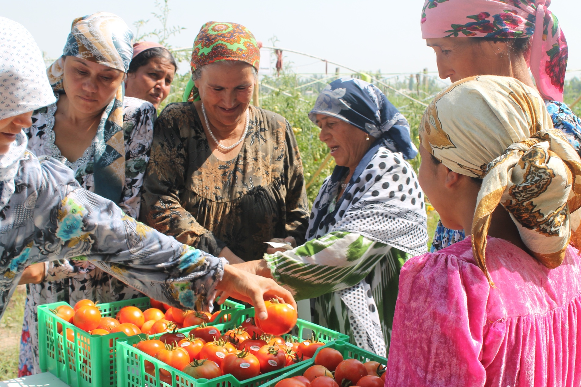

Photo Credit: [Name]

ACKNOWLEDGMENTS
[Update based on the report. An example is provided below.]

[Name], [Title], and [Name], [Title] researched and wrote this gender and WEEGE integration plan with support from [Name], [Title], under the direction of [Name], [Title], [Organization]. Additional support was provided by [Name], [Title]. The authors developed this publication with guidance from the United States Agency for International Development, particularly [Name], [Title], [Office].

The team expresses its gratitude to [prime] and [subs] and special thanks to [Name], [Name], [Name], [Name], [Name], [Name], [Name], and [Name].

For further information, please contact:
[Enter name and organization]
[Enter address]
[Enter Phone: +]
[Enter Fax: +]

ACRONYMS
[Update based on acronyms used in the report. If an acronym appears in the body of the report, it needs to be referenced here. When using an acronym for the first time in the body of the report, spell it out completely. For example: “The United States Agency for International Development (USAID) is responsible for…”]

IP | Implementing partner
USAID | United States Agency for International Development
WEEGE | Women’s economic empowerment and gender equality

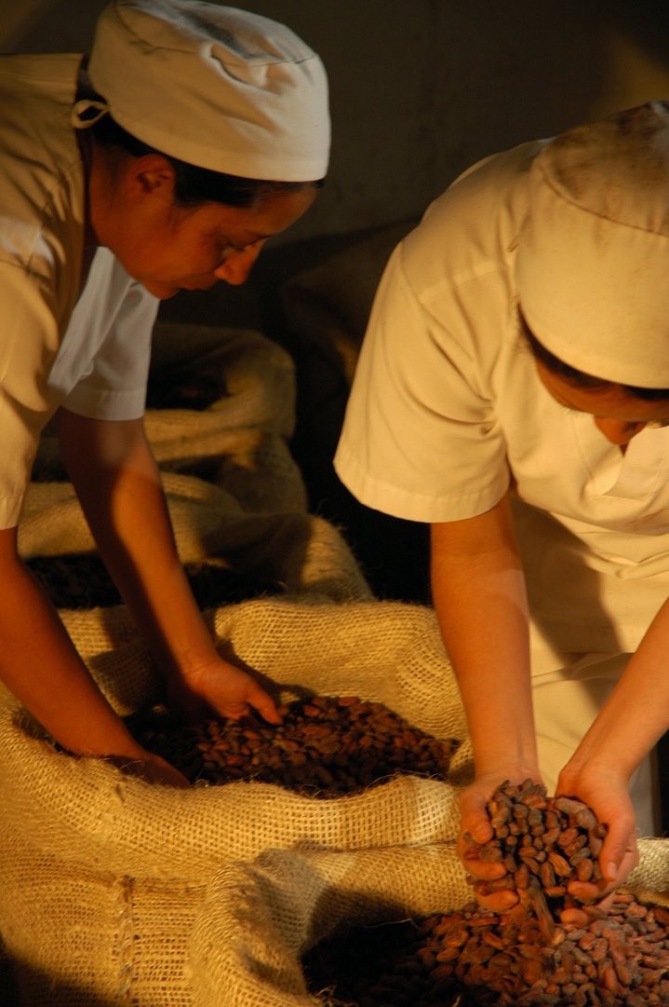
KEY TERMS AND DEFINITIONS
[Examples follow. Update based on key terms used in the report.]

Allyship: Supportive association with another person or group, specifically, with the members of a marginalized or mistreated group to which one does not belong.

Critical mass in politics: Critical mass for women’s involvement in politics is generally agreed to be 30 percent.

Gender balance: Gender balance is generally agreed to be a male-female ratio of between 40 and 60 percent. McKinsey, a global consulting firm, analyzed data from 50,000 managers across 90 entities around the world and found that teams with a male-female ratio between 40 and 60 percent produce performance indicators that are more sustained and predictable than unbalanced teams, in terms of employee engagement, brand awareness, client retention, and financial metrics.

Gender-based violence: An umbrella term for any harmful threat or act directed at an individual or group based on actual or perceived biological sex, gender identity or expression, sexual orientation, or lack of adherence to socially constructed norms around masculinity and femininity. It is rooted in structural gender inequalities, patriarchy, and power imbalances. GBV is typically characterized by the use (or threat) of physical, psychological, sexual, economic, legal, political, or social coercion, control, or abuse. GBV impacts individuals across the life course, and it has direct and indirect costs to families, communities, economies, global public health, and development. GBV takes many forms and can occur throughout the life cycle. Types of gender-based violence include: female infanticide; child sexual abuse; sex trafficking and forced labor; sexual coercion and abuse; neglect; domestic violence; elder abuse; and harmful traditional practices such as early and forced marriage, honor killings and female genital mutilation and cutting.
Photo Credit: [Name]

Positive masculinities: A term used to characterize the values, norms, and practices that gender-based work with men and boys seeks to promote to end violence against women and girls.

Value chain: The full range of activities that are required to bring a product from its conception to its end use. These include design, production, marketing, distribution, and support to get the product to the final consumer. The activities that comprise a value chain can be contained within a single firm or many firms.

Women’s economic empowerment and gender equality (working definition): Women’s economic empowerment exists when women can equitably participate in, contribute to, and benefit from economic opportunities as workers, consumers, entrepreneurs, and investors. This requires access to and control over assets and resources, as well as the capability and agency to manage the terms of their own labor and the benefits accrued. Women’s economic equality exists when all women and girls have the same opportunities as men and boys for education, economic participation, decision-making, and freedom from violence. This requires collectively addressing barriers to commercial activity and labor market participation, such as restrictive laws, policies, and cultural norms; infrastructure and technology challenges; unpaid care work; limits on collective action; and poorly enforced protections. Women's economic equality is just one facet of gender equality more generally, which requires attention to the full range of gender gaps - economic, political, educational, social and otherwise.

BACKGROUND AND CONTEXT

[Provide country context within which the activity is taking place. Remember to include key historical context, current events impacting the context, and key actors.]

[Summarize the USAID-funded activity. Include information about the funding office, timeline, development objectives, results, intermediate results, and any cross-cutting themes or objectives the activity supports, as well as the outputs and outcomes the activity aims to achieve. Contextualize how the gender analysis with a WEEGE lens informs the activity and how key interventions will achieve activity goals/outcomes.]

TABLE 1. EXAMPLE TABLE
TABLE HEADING | TABLE HEADING | TABLE HEADING
Table text | Table text | Table Text
Table text | Table text | Table Text
Table text | Table text | Table Text

APPROACH

[Describe the approach and process used to guide the integration of women’s economic empowerment and gender equality, including the activity-level gender analysis with a WEEGE lens and references to other evidence-based approaches. Include information on both external stakeholder consultations and workshops and internal consultation with project staff, relating to potential interventions to be included in the activity work plan.]

EXAMPLE
The activity-level WEEGE integration plan approach aims to economically empower women through the activity without (directly or indirectly) causing them harm. Activities should not, for example, increase women’s burden of unremunerated labor, erode their social standing at the community or household level, or worsen their access to productive resources or returns from employment of those resources. Using the Unit 3, Toolbox: Integrating WEEGE into a Gender Analysis, the gender analysis will use both qualitative and quantitative methods to understand the current WEEGE barriers and opportunities related to the activity theory of change. A wide variety of stakeholders from government, civil society, and the private sector—with an intentional emphasis on women’s organizations, networks, and businesses—will be engaged. IP staff, including IP leadership, also will be interviewed. In addition, the labor market assessment and the environmental assessment will draw upon the Unit 3, Toolbox: Part III: WEEGE Illustrative Questions to ensure that WEEGE considerations and findings are used in the integration plan.

OBJECTIVES

[Provide an overview of the WEEGE integration objectives, including the vision for women’s economic empowerment and gender equality. Additionally, list any WEEGE Principles or Unit 3, Toolbox: Part III: WEEGE Illustrative Questions upon which the integration plan is based.]

EXAMPLES
- Increase knowledge generation on gender, new masculinities, and family co-responsibility, among service providers and civil society organizations.
- Generate public opinion as well as cultural and behavioral change at the municipal level regarding women’s economic empowerment and gender equality.
- Support women in leadership and management roles and increase their decision-making authority.
- Support women in being competitive and safe, while accessing new value chains or expanding their role in existing value chains.

ANALYSES WITH A WEEGE LENS

FINDINGS
[Articulate findings from activity-level gender analysis with a WEEGE lens or other analyses. (Select this link for the Unit 3, Toolbox: Integrating WEEGE into a Gender Analysis.) Ideally, the analyses will be completed early enough so that the findings can be integrated into IP activity theory of change, work plan, and monitoring and evaluation plan before submission to USAID for approval.]

[Discuss how the findings are expected to be used to inform decision-making. Findings can be described as they relate to the activity/sector/cross-cutting themes.]

[Describe any additional key women’s economic empowerment and gender equality research reports and findings that should inform activity design and implementation. Select this link for Unit 1, Resource 1: Data Sources and Unit 2 repository of resources for guidance. Include references to any pertinent U.S. Government and USAID documents or policies related to the activity.]

RECOMMENDATIONS
[Articulate the overall recommendations from the gender analysis integrating WEEGE and other analyses. These recommendations should inform women’s economic empowerment and gender equality integration for the life of the activity, while addressing the most critical constraints, proposing targets and outcomes, and referring to required budget resources.]

CONCLUSIONS

[Describe how priority recommendations can be addressed and how they help achieve activity outcomes. Discuss the process—including information on who, what, when, where, and how—for integrating priority recommendations into the theory of change, work plan, and MEL plan.]

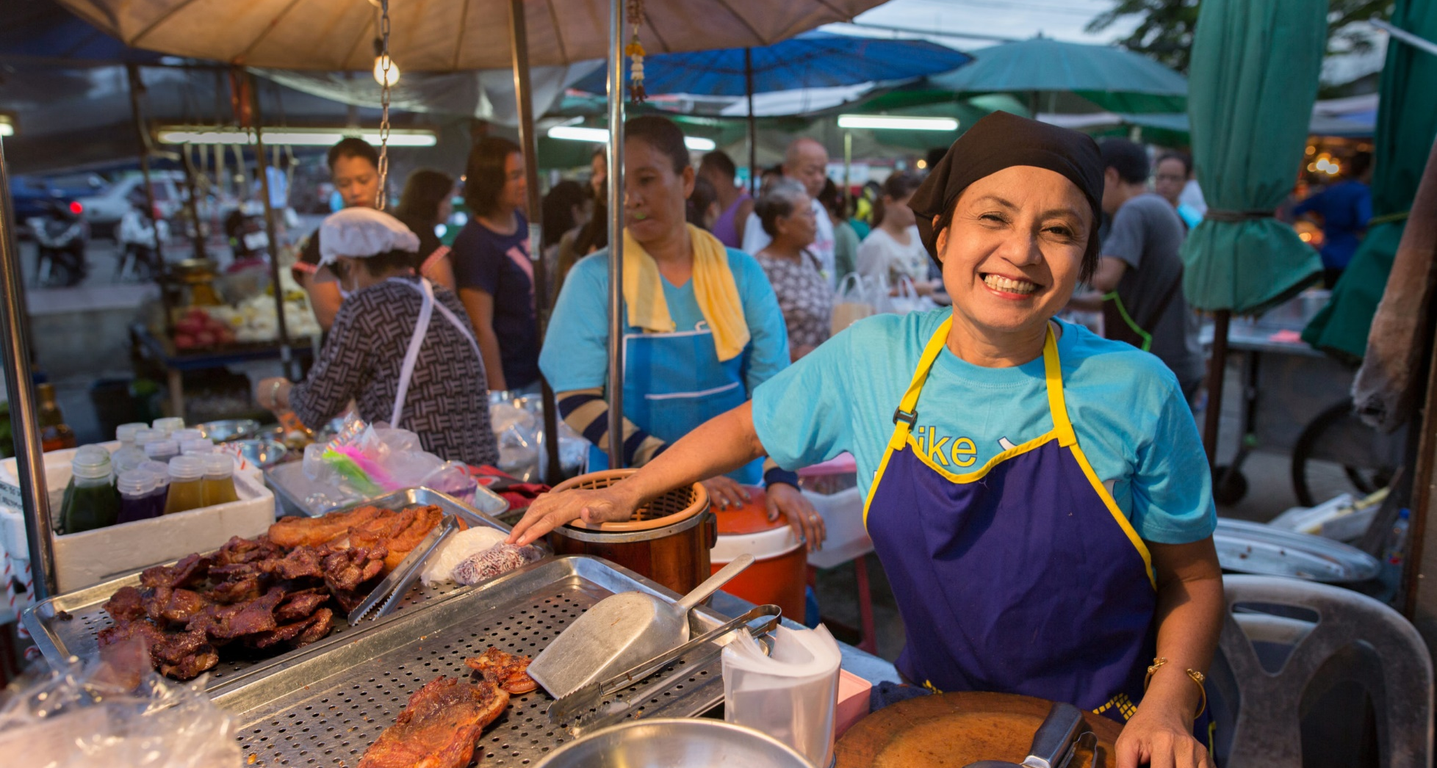
Photo Credit: [Name]

ANNEXES

A WEEGE integration plan will likely include annexes related to the gender analysis with a WEEGE lens or to the integration plan, or both. Select this link for the Unit 3, Toolbox: Integrating WEEGE into a Gender Analysis and the suggested annexes listed in the Unit 3, Toolbox: Part V: Inception Report Template and Unit 3, Toolbox: Part VIII: Final Report Template.

Other integration plan annexes may include the two shown here:
ANNEX A: | Illustrative Integration Checklist
ANNEX B: | Illustrative Integration Sub-activities

[Include additional annexes to attach the updated theory of change, updated work plan, or updated monitoring, evaluation and learning plan, as needed.]

ANNEX A: ILLUSTRATIVE INTEGRATION CHECKLIST
[If useful, use the illustrative integration checklist to have a conversation about how to integrate WEEGE into the activity.]
TABLE 2. ILLUSTRATIVE INTEGRATION CHECKLIST
CHECKLIST |  |  | RESPONSE |  | NOTES
DESIGN DURING PLANNING
- What existing social, economic, cultural, and legal barriers or challenges were found in the activity-level gender analysis integrating WEEGE? How can they be overcome, minimized, or removed through the activity?
- Have the findings been integrated into the theory of change? How?
- What WEEGE indicators will be regularly monitored, and what sex- and age-disaggregated data is collected to inform the desired integration outcome from this activity?
- How will the planned integration sub-activity, related process, or results improve opportunities and economic empowerment (or limit opportunities and restrict empowerment) for women and girls?
- Is this activity meant for both women and men, boys and girls? If so, what specific strategies and sub-activities should be used to reach and mobilize women and men, boys and girls?
- What opportunities does the activity provide for meaningful engagement of adolescent girls and boys and building their capabilities?
- What risks are women, girls, men or boys likely to face as a result of participating in this activity? How can the activity reduce these risks?
- Is there an accessible feedback mechanism to voice staff and community member concerns on anything related to the planned activity, other activities, or the project in general?
- Are attendance/participation of women, men, boys and girls being captured on age- and sex-disaggregated attendance sheets or record books?
DURING IMPLEMENTATION |  | RESPONSE |  |  | NOTES
- Do women and men, boys and girls have equitable opportunity to participate in the sub-activity? Are their voices and perspectives being heard and acted upon?
- Is the sub-activity being held at a time and location that is convenient and safe for women, men, boys, and girls (of different ages, backgrounds, and social identities) to attend?
- Do activity and leadership committees, if any, include equal and fair numbers of women and men, and adolescent girls and boys, enabling their ideas to be considered?
DURING MONITORING AND LEARNING |  | RESPONSE |  |  | NOTES
- What sex- and age-disaggregated data do we have to understand the WEEGE benefits of the activity?
- What are potential areas for follow-up to make the activity more effective for WEEGE?
- What are the challenges and lessons learned from WEEGE integration sub-activities? Are approaches being adapted to address these challenges?
- How are lessons learned being incorporated into other activities?
DURING EVALUATION |  | RESPONSE |  |  | NOTES
- Did the activity generate the intended women’s economic empowerment and gender equality outcomes? Did the theory of change hold?
- What unanticipated positive and negative effects resulted from the activity?
- What WEEGE information can be shared with other key actors?

ANNEX B: ILLUSTRATIVE SUB-ACTIVITIES FOR ACTIVITY WORK PLAN

The findings and recommendations from the activity-level gender analysis with a WEEGE lens and other analyses should be used to inform the theory of change and the related sub-activities in the activity work plan. Work plans typically further indicate the intended outcomes and resources required for each sub-activity. Table 3 provides an illustrative list of integration sub-activities that may be included in the work plan.

TABLE 3. ILLUSTRATIVE SUB-ACTIVITIES
1 | Collaborate with cooperatives to promote women’s membership and leadership in collective groups.
2 | Provide assistance to support women and girl’s access to improved technology and services.
3 | Support the activity’s social and behavior change communication messaging to broaden society’s understanding of the differential impacts of and access to water and sanitation on women/men and girls/boys as well as to promote the sharing of related responsibilities.
4 | Design and support business internships and mentorship programs for women.
5 | Work with banks, saving and credit cooperative organizations, and microfinance institutions to address women’s financial service needs and use of guaranteed loans.
6 | Pilot digital financial services and savings programs for young women, including targeted savings goals.
7 | Support business training through partner organizations and business development service providers for female farmers and women-owned businesses with information related to record keeping, analyzing production costs, business planning, accessing market information, packaging, and financing options.
8 | Provide project resources to support women business leaders’ participation in trade fairs and obtaining new contracts.
9 | Support activity staff to identify women-owned businesses to serve as lead firms for ongoing technical assistance to agribusinesses and agro-processors.
10 | Ensure that price and market information are provided through mechanisms that women have access to.
11 | Assist the activity staff to integrate women’s economic empowerment and gender equality considerations into its research, policy documents, and studies.
12 | Hold orientation training and ongoing learning sessions for all staff and partners, to build their capacity on these topics and uniformly represent the project in this area.

Miriam Webster Dictionary online: https://www.merriam-webster.com/dictionary/allyship
Reference also Dahlerup, D. (2006), The story of the theory of critical mass. Politics & Gender 2 (4): 511–522.
Landel, M. (2015), Gender balance and the link to performance. Available at https://www.mckinsey.com/featured-insights/leadership/gender-balance-and-the-link-to-performance
U.S. Department of State (2016), United States strategy to prevent and respond to gender-based violence globally. Available at https://www.state.gov/wp-content/uploads/2019/03/258703.pdf
USAID (2015). Working with Men and Boys to End Violence Against Women and Girls: Approaches, Challenges, and Lessons. Available at https://www.usaid.gov/sites/default/files/Sector-5-SocialDev_MenandBoys.pdf
USAID (2005). microNOTE #6 AMAP BDS Knowledge and Practice Task Order - Lexicon. Available at https://www.marketlinks.org/sites/default/files/resource/files/ML1778_mn_6_lexicon_03_05.pdf
This is not an official definition of USAID or any other organization but rather a practical working definition that provides sufficient clarity in pursuing USAID’s economic goals with regard to gender equality and female empowerment

