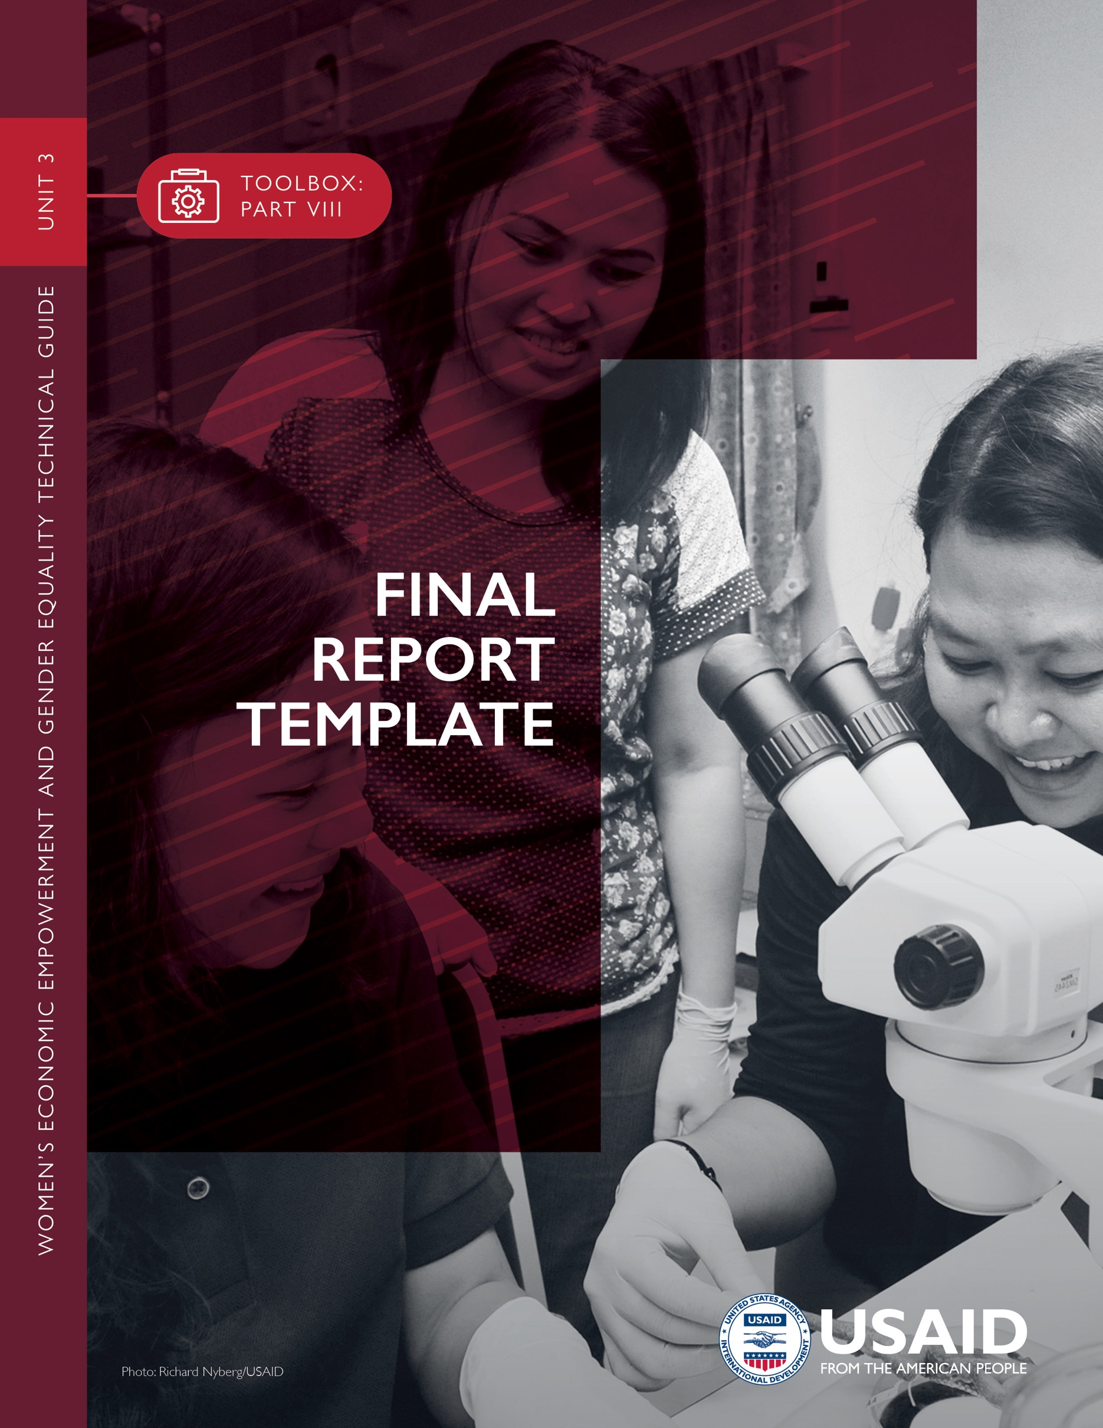

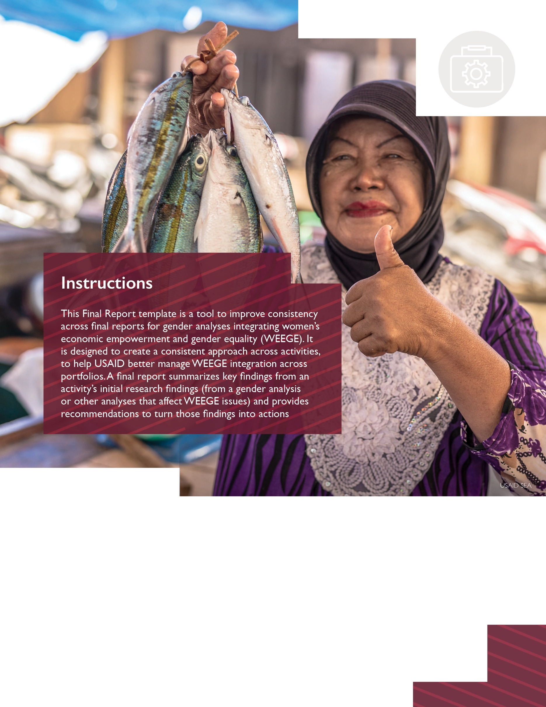

When using this template, delete all instructions [shown in brackets] and replace all headings and text with your own content. Please note that this template is based on the USAID Graphic Standards Manual and Partner Co-Branding Guide revised in February 2020. To ensure that the plan adheres to the most recent information and templates, visit https://www.usaid.gov/branding/. Please also refer to the ADS Style and Format Guide: A Mandatory Reference for ADS Chapter 501.

The template starts on the next page
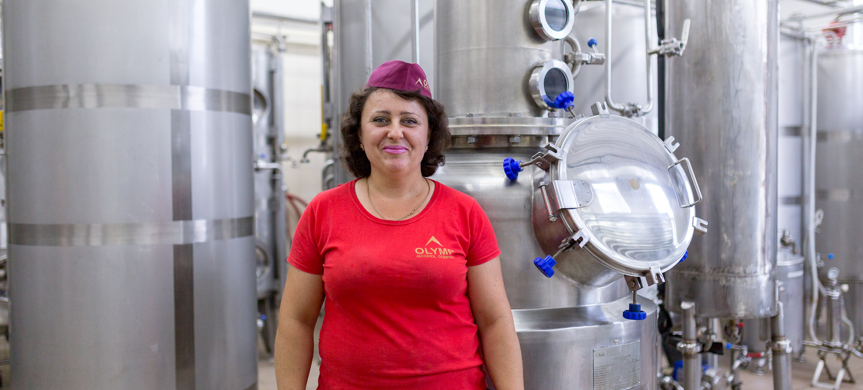

Photo Credit: [Name]

ACTIVITY NAME GOES HERE
[EXAMPLE: WOMEN’S ECONOMIC EMPOWERMENT AND EQUALITY TECHNICAL ASSISTANCE TASK ORDER]
REPORT TITLE GOES HERE
[EXAMPLE: INTEGRATING WOMEN’S ECONOMIC EMPOWERMENT AND GENDER EQUALITY IN LABOR, SMALL AND MEDIUM ENTERPRISE DEVELOPMENT AND THE ENABLING ENVIRONMENT — FINAL REPORT]
Optional Subtitle Can Go Here
[INSTRUCTIONS: DELETE THIS BOX IN FINAL TEMPLATE]

The title should be informative, with no acronyms and no implementing partner names.
[Change the cover photo to one that is relevant to the context, and update photo credit accordingly. To change a placeholder photo: 1. Right-click placeholder photo, 2. Select “Change Photo”, 3. Choose “From a File”, 4. Select desired photo from computer, 5. Click “Insert”]"

ACTIVITY NAME
REPORT TITLE
Optional Subtitle

[MONTH DAY, YEAR]
PROJECT NUMBER: [INSERT NUMBER, IF ONE EXISTS]

FUNDING MECHANISM NUMBER [INSERT NUMBER]
SUBMITTED TO: [ENTER NAMES AND TITLES]
DEVELOPMENT EXPERIENCE CLEARINGHOUSE CATALOGUE NUMBER [IF REQUESTED IN ADVANCE OF PUBLICATION]

DISCLAIMER [if report is not authored by USAID]
This document was produced for review by the United States Agency for International Development. It was prepared by [organization] for [project/activity name]. The author’s views expressed in this publication do not necessarily reflect the views of the United States Agency for International Development or the United States Government.

RECOMMENDED CITATION [Insert Team Names (Last, First, Title/Suffix if applicable).
USAID/(Country), Report Title. Prepared by (organization). (year).]

TABLE OF CONTENTS

TABLE OF FIGURES / LIST OF TABLES iii
ACKNOWLEDGMENTS iv
ACRONYMS v
KEY TERMS AND DEFINITIONS vi
EXECUTIVE SUMMARY 1
BACKGROUND AND CONTEXT 1
PURPOSE AND QUESTIONS 1
DESIGN, METHODOLOGY AND LIMITATIONS 1
FINDINGS, CONCLUSIONS AND RECOMMENDATIONS 1
BACKGROUND AND CONTEXT 2
PURPOSE AND QUESTIONS 3
PURPOSE 3
QUESTIONS 3
DESIGN, METHODOLOGY AND LIMITATIONS 4
DESIGN 4
METHODOLOGY 4
LIMITATIONS 4
FINDINGS, CONCLUSIONS AND RECOMMENDATIONS 5
FINDINGS 5
CONCLUSIONS 5
RECOMMENDATIONS 5
ANNEXES 6
ANNEX A: SCOPE OF WORK FOR A GENDER ANALYSIS INTEGRATING WEEGE 7
ANNEX B: LITERATURE REVIEW 8
ANNEX C: REFERENCES 9
ANNEX D: KEY INFORMANT INTERVIEWS 10
ANNEX E: KEY DATA AND STATISTICS 11
ANNEX F: LEGAL AND INSTITUTIONAL FRAMEWORK 13
ANNEX G: RELEVANT ORGANIZATIONS 14
ANNEX H: RESOURCES 15

[Update the table of contents when you finalize the report: Select the text that says Table of Contents. A blue box should appear, select the arrow in the blue box at top left and select “update table.” Alternatively, right click on the table and then select “update field.”]

TABLE OF FIGURES / LIST OF TABLES
[Update the content and title of this list based on figures, boxes, or tables used in the report. To allow for a table of figures to pull from the document, insert a caption on any figure, table, or box. Right click on the respected item in the document you wish to label and then select “insert caption.” Then label the item accordingly. Make sure the caption still follows USAID’s style in fonts and size. An example follows.]

TABLE 1. EXAMPLE TABLE iii
TABLE 2. EXAMPLE KEY INFORMANT INTERVIEWS 10
TABLE 3. EXAMPLE LABOR AND EMPLOYMENT 11
TABLE 4. EXAMPLE SOLID WASTE MANAGEMENT AND RECYCLING LEGISLATION 12
TABLE 5. EXAMPLE RELEVANT ORGANIZATIONS 13
TABLE 6. EXAMPLE RESOURCES 14

TABLE 1. EXAMPLE TABLE
THIS IS AN EXAMPLE TABLE | USE THE COLORS SHOWN HERE FOR HEADINGS | ADD DIFFERENT LINES
Table text | Table text | Table text
Table text | Table text | Table text
Table text | Table text | Table text

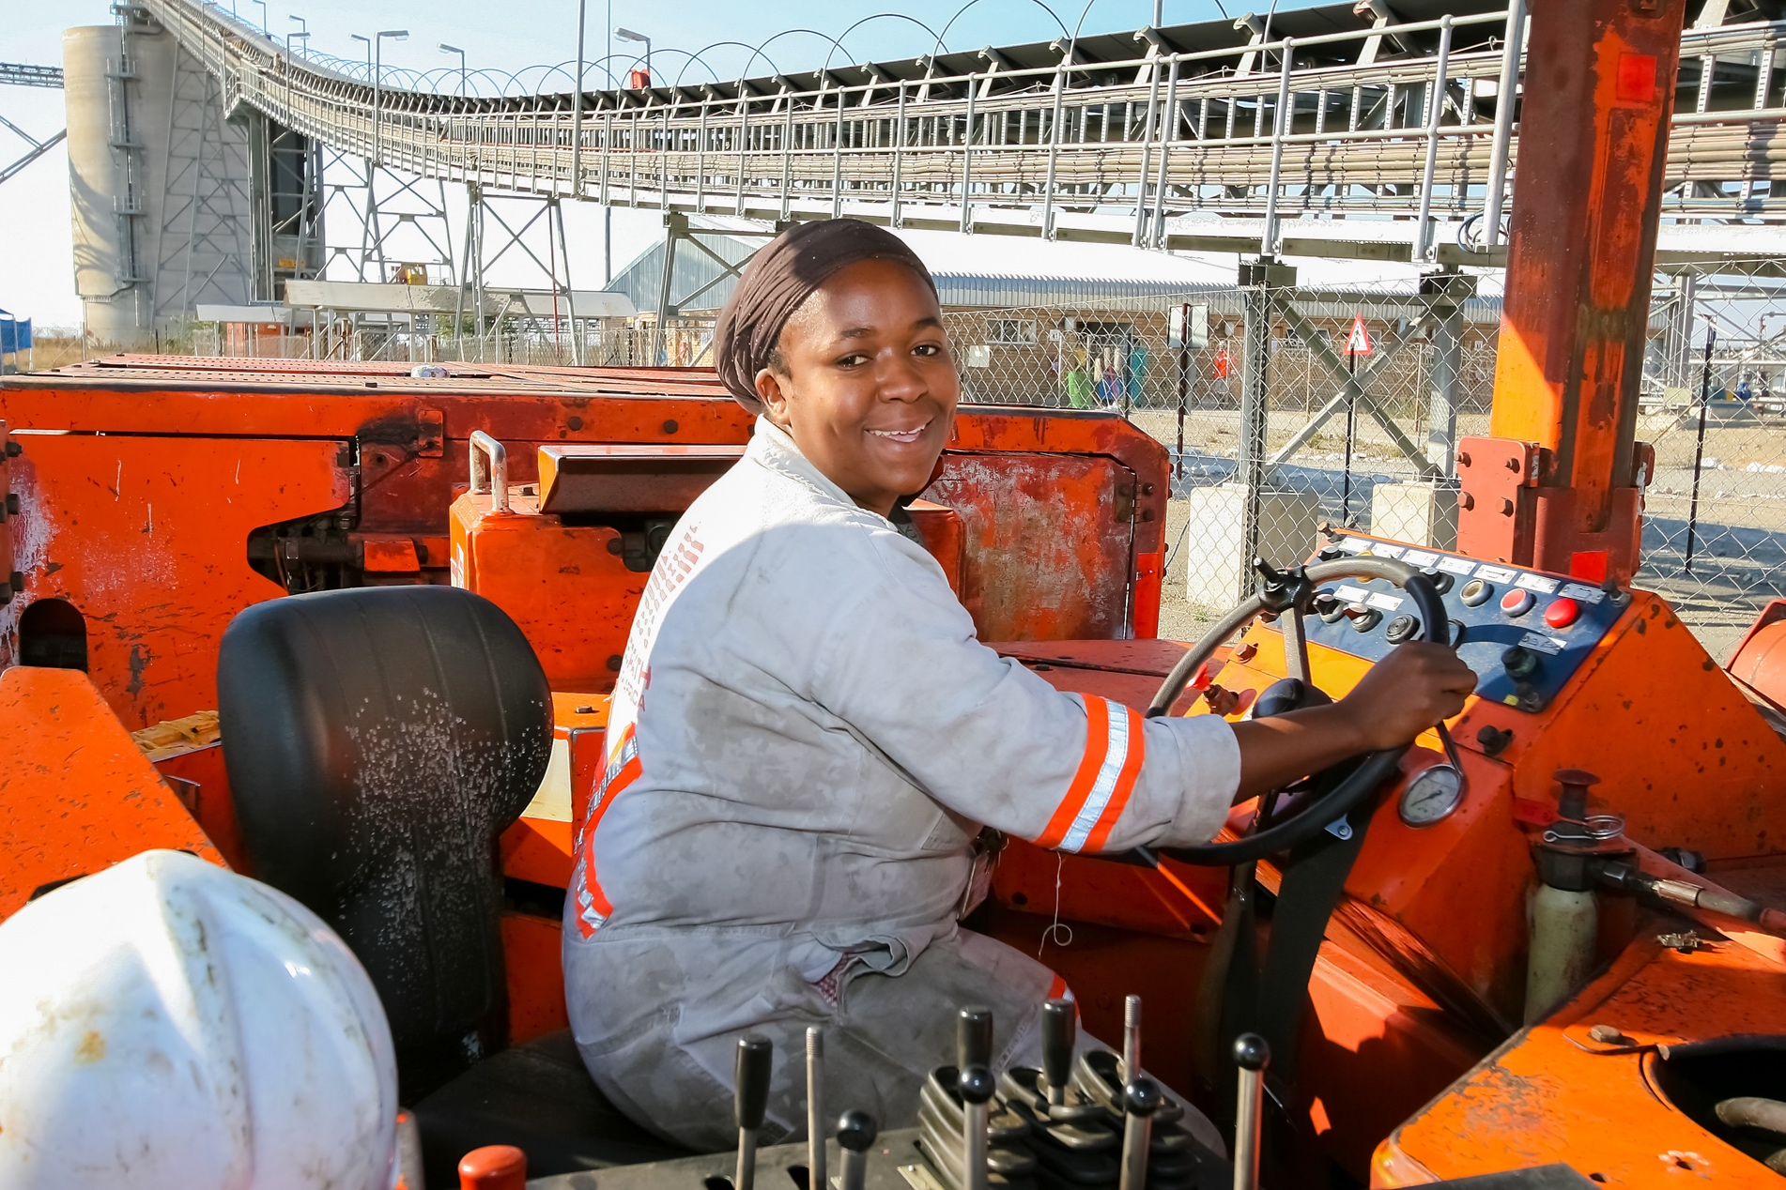

Photo Credit: [Name]

ACKNOWLEDGMENTS
[Update based on the report. An example is provided below.]

[Name], [Title] and [Name], [Title] researched and wrote this report with support from [Name], [Title], under the direction of [Name], [Title] [Organization]. Additional support was provided by [Name], [Title]. The authors developed this publication with guidance from the United States Agency for International Development, particularly [Name], [Title], [Office].

The team expresses its gratitude to USAID [office] and [office] and USAID missions in [Countries] with special thanks to [Name], [Name], [Name], [Name], [Name], [Name], [Name], and [Name].

For further information, please contact:
[Enter name and organization]
[Enter address]
[Enter Phone: +]
[Enter Fax: +]

ACRONYMS
[Update based on acronyms used in the report. If an acronym appears in the body of the report, it needs to be referenced here. When using an acronym for the first time in the body of the report, spell it out completely. For example: “The United States Agency for International Development (USAID) is responsible for…”]

ADS | Automated Directives System
DEC | Development Experience Clearinghouse
GBV | Gender-based violence
GenDev | Gender Equality and Women’s Empowerment Hub
SOW | Scope of work
USAID | United States Agency for International Development
WEEGE | Women’s economic empowerment and gender equality

KEY TERMS AND DEFINITIONS
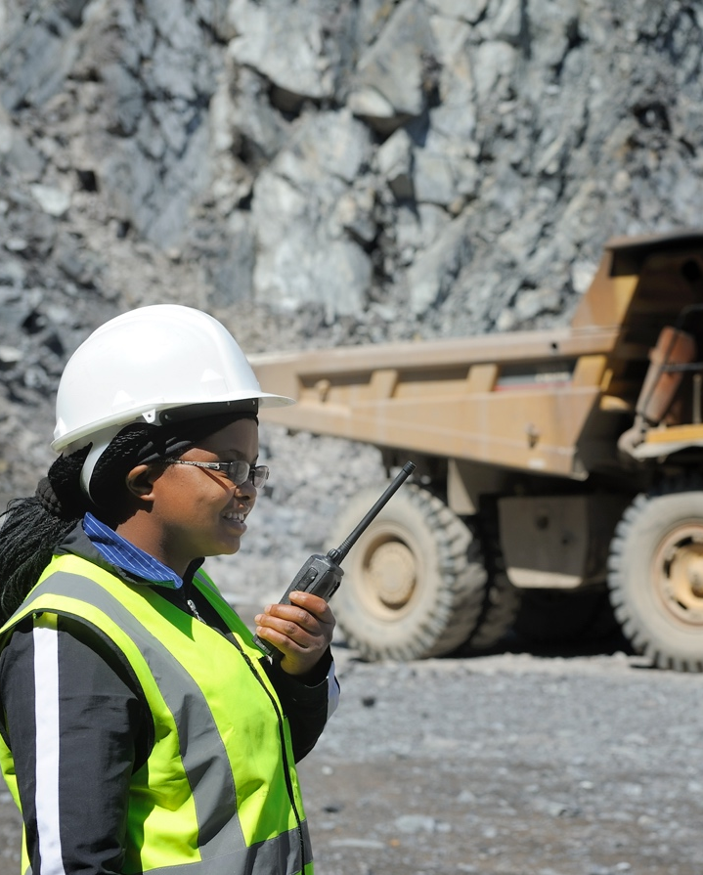
[Examples follow. Update based on key terms used in the report.]

Allyship: Supportive association with another person or group; specifically, with the members of a marginalized or mistreated group to which one does not belong.
Critical mass in politics: Critical mass for women’s involvement in politics is generally agreed to be 30 percent.
Gender balance: Gender balance is generally agreed to be a male-female ratio of between 40 and 60 percent. McKinsey, a global consulting firm, analyzed data from 50,000 managers across 90 entities around the world and found that teams with a male-female ratio between 40 and 60 percent produce performance indicators that are more sustained and predictable than unbalanced teams in terms of employee engagement, brand awareness, client retention and financial metrics.
Gender-based violence (GBV): An umbrella term for any harmful threat or act directed at an individual or group based on actual or perceived biological sex, gender identity or expression, sexual orientation, or lack of adherence to socially constructed norms around masculinity and femininity. It is rooted in structural gender inequalities, patriarchy, and power imbalances. GBV is typically characterized by the use (or threat) of physical, psychological, sexual, economic, legal, political, or social coercion, control, or abuse. GBV impacts individuals across the life course, and it has direct and indirect costs to families, communities, economies, global public health, and development. GBV takes many forms and can occur throughout the lifecycle. Types of gender-based violence include: female infanticide; child sexual abuse; sex trafficking and forced labor; sexual coercion and abuse; neglect; domestic violence; elder abuse; and harmful traditional practices such as early and forced marriage, honor killings, and female genital mutilation and cutting.
Photo Credit: [Name]
Positive masculinities: A term used to characterize the values, norms, and practices that gender-based work with men and boys seeks to promote, to end violence against women and girls.

Value chain: The full range of activities that are required to bring a product from its conception to its end use. These include design, production, marketing, distribution, and support to get the product to the final consumer. The activities that comprise a value chain can be contained within a single firm or many firms.
Women’s economic empowerment and gender equality (working definition): Women’s economic empowerment exists when women can equitably participate in, contribute to, and benefit from economic opportunities as workers, consumers, entrepreneurs, and investors. This requires access to and control over assets and resources, as well as the capability and agency to manage the terms of their own labor and the benefits accrued. Women’s economic equality exists when all women and girls have the same opportunities as men and boys for education, economic participation, decision-making, and freedom from violence. This requires collectively addressing barriers to commercial activity and labor market participation, such as restrictive laws, policies, and cultural norms; infrastructure and technology challenges; unpaid care work; limits on collective action; and poorly enforced protections. Women's economic equality is just one facet of gender equality more generally, which requires attention to the full range of gender gaps—economic, political, educational, social and otherwise.

EXECUTIVE SUMMARY
[The Executive Summary should stand alone as a summary of the key sections of the report and should summarize the content of the full report without adding new information. The Executive Summary ideally should be three to five pages.]

BACKGROUND AND CONTEXT
[Summarize the current status of the USAID strategies, policies and programming, as relevant. Describe the USAID and/or implementing partner gender analysis request and specify the level of gender analysis with a WEEGE lens (country, project or activity). Contextualize how the gender analysis fits within the program portfolio.]
[Provide the global, regional or country context in which the gender analysis is taking place. Remember to include key historical context, current events impacting the context, and key actors.]

PURPOSE AND QUESTIONS
[Summarize the overarching purpose of the gender analysis, its emphasis on women’s economic empowerment and gender equality, and how the findings and recommendations are expected to be used to inform decision-making. Describe the main audiences for the report.]
[Describe the intentional integration of W4 into the research questions, guided by Part III: WEEGE Illustrative Questions. Use three to five research questions at most.]

DESIGN, METHODOLOGY AND LIMITATIONS
[Discuss: overall methods and design; specific data collection and analysis methods linked to the research questions; and limitations of the data and methods, or other issues that affected the findings. Highlight gaps in data identified during the literature review phase of the analysis using Part IV: WEEGE Literature Review Worksheet, and indicate whether researchers used this information to prioritize field research.]

FINDINGS, CONCLUSIONS AND RECOMMENDATIONS
[Summarize findings based on evidence generated by the literature review and field-based data collection and analysis. Findings should be fact-based and not rely only on opinion. Recommendations should be drawn from findings and made actionable within the context of USAID. Several findings can lead to one or more conclusions and recommendations. Whenever possible, data should be presented visually in easy-to-read charts, tables, graphs and maps, to demonstrate the evidence that supports the conclusions and recommendations and meets the needs of the target audience.]

BACKGROUND AND CONTEXT
[Summarize the current status of the USAID strategies, policies and programming, as relevant. Describe the USAID and/or implementing partner gender analysis request, and specify the level of gender analysis with a WEEGE lens (country, project or activity). Contextualize how the gender analysis fits within the program portfolio.]
[Provide the global, regional or country context in which the gender analysis is taking place. Remember to include key historical context, current events impacting the context, and key actors.]

PURPOSE AND QUESTIONS

PURPOSE
[Summarize the overarching purpose of the gender analysis, its emphasis on women’s economic empowerment and gender equality, and how the findings and recommendations are expected to inform decision-making. Describe the main audiences for the report. Reference the scope of work for the gender analysis and include it in Annex A: Scope of Work for a Gender Analysis Integrating WEEGE.]

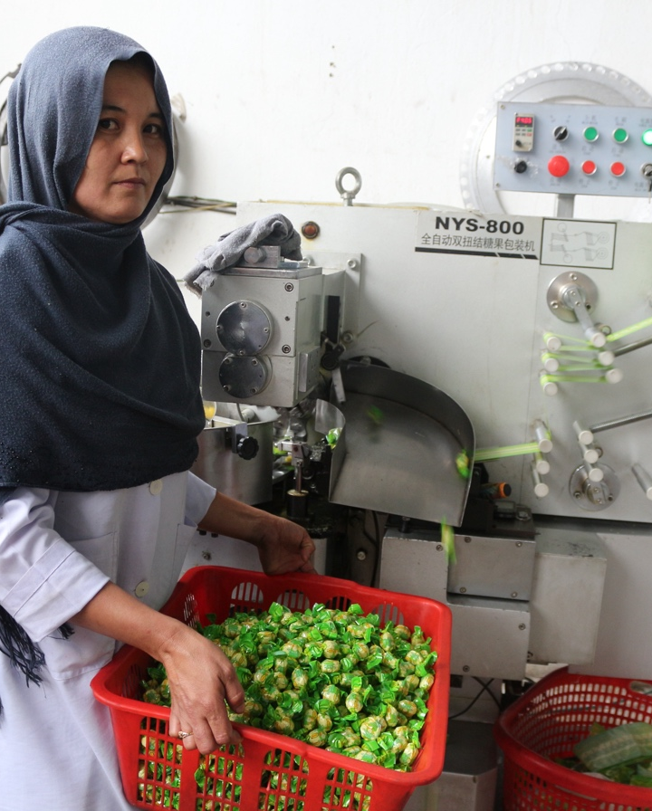
QUESTIONS
[List the research questions for the study. Good practice is to limit the questions to between three and five that are clear and focused and will inform specific decisions. Refer to Part III: WEEGE Illustrative Questions to ensure that research questions intentionally integrate WEEGE. At least one research question should explicitly seek to understand the barriers or opportunities for women’s economic empowerment in relevant sectors or regions.]
Photo Credit: [Name]

DESIGN, METHODOLOGY AND LIMITATIONS

DESIGN
[What were the research-design concepts used and how were they implemented? For example, what qualitative measures and quantitative measures were used? Describe how you identified interviewees and the process for setting up and conducting key informant interviews (KIIs) and focus group discussions (including whether interviews were conducted remotely or in person). Describe any other data-collection methods and the types of tools used to collect the data, such as surveys, forms, software, recording devices and/or translation services.]

METHODOLOGY
[Provide a detailed description of the methods employed during the gender analysis with a WEEGE lens, and why they were chosen. Provide information on all aspects of the analysis design and methodology, including but not limited to: trade-offs and limitations that led to the selection of specific data collection and analysis methods; a description of data availability and quality; and sampling strategies (purposeful or random), including how interviewees or site visits were selected.]
[The chosen research methods should correspond to the types of questions being asked and should generate the highest quality and most credible evidence possible, taking into consideration time, budget and other practical considerations. Methods also should reflect principles of gender equality and female empowerment, and prioritize participatory and horizontal interactions with stakeholders, key informants and focus group participants. To show the relationships between research questions and methods, it may be useful to include a chart listing each question along with the corresponding methods used for data collection and analysis, data sources, sample sizes and limitations.]
[List any documents reviewed, sites visited or any other information sources accessed during the literature review in Annex B: Literature Review and Annex C: References. Outline the process of data collection, including the timeline, a preliminary schedule, proposed location and scope (such as global, regional, country and local). If primary data collection included key informant interviews, then complete and reference Annex IV: Key Informant Interviews.]
[Describe measures taken to ensure the protection of informant information. If vulnerable individuals, particularly children and youth with no legal authority, were interviewed, or if the interview discussed sensitive subject matters, detail the alignment with the common federal policy for the protection of human subjects, Part 225 of Title 22 of the Code of Federal Regulations, as well as the Procedures for the Protection of Human Subjects in Research Supported by USAID; specify any necessary approvals received.]
[Discuss data as a snapshot in time or over time, and/or in relation to other countries. Include information on the gaps in WEEGE-related quantitative data globally, regionally and/or at the country level; be sure to contextualize information based on available data.]

LIMITATIONS
[Describe any limitations in data collection and analysis, data quality or access to data sources that may have resulted in biases, including remote versus in-person interviews. Describe limitations in the ability to travel, access to necessary interviewees or other barriers faced in data collection. Discuss the generalizability of the information gathered: for example, is the information and analysis gathered in this research applicable to other countries, regions or cities?]

FINDINGS, CONCLUSIONS AND RECOMMENDATIONS

FINDINGS
[Findings come directly from the data collected during the gender analysis, in both the literature review and field research. Synthesize key findings, conclusions and recommendations from the gender analysis with a WEEGE lens, and present them in an easy-to-understand and logical fashion. Whenever possible, data should be summarized and presented visually in easy-to-read charts, tables, graphs and maps to demonstrate the evidence that supports the conclusions and recommendations.]

CONCLUSIONS
[Conclusions synthesize and interpret findings and make judgments supported by one or more specific findings. Interpretations should align with USAID’s values and principles, as expressed in the Gender Equality and Female Empowerment Policy.]

RECOMMENDATIONS
[Recommendations are specific actions the research team proposes that either USAID or the implementing partner take, based on the findings and conclusions. The reader should be able to discern what evidence supports the conclusions and recommendations.]
[Use relevant annexes—Annex E: Key Data and Statistics, Annex F: Legal and Institutional Framework, Annex G: Relevant Organizations; and Annex H: Resources—to capture detailed information that supports the findings, conclusions and recommendations.]

ANNEXES

Final reports for gender analyses with a WEEGE lens will likely include the following annexes:

Annex A: | Scope of Work for a Gender Analysis Integrating WEEGE
Annex B: | Literature Review
Annex C: | References
Annex D: | Key Informant Interviews
Annex E: | Key Data and Statistics
Annex F: | Legal and Institutional Framework
Annex G: | Relevant Organizations
Annex H: | Resources

[Include additional annexes if needed.]

ANNEX A: SCOPE OF WORK FOR A GENDER ANALYSIS INTEGRATING WEEGE
[Insert the final scope of work approved by USAID that guided the research team.]
[For guidance on how to draft a scope of work, refer to Part II: Integrating WEEGE into a Gender Analysis SOW.]

ANNEX B: LITERATURE REVIEW
[List any documents reviewed, sites visited, or any other information sources accessed during the literature review for the gender analysis with a WEEGE lens.]
[Review documents related to the ADS 205 domains: laws, policies, and regulations; cultural norms and beliefs; gender roles, responsibilities, and time use; access to and control over assets and resources; and patterns of power and decision-making—as well as the WEEGE categories of markets, finance, decent work and income, assets and human capital.]

[Sources should be referenced in the following way:
Last name, First Initial. (Year). Title of Document, Title of Source. Link (if website or accessed online).]

ANNEX C: REFERENCES
[List additional references that are cited in the final report but were not part of the desk review.]
[Sources should be referenced in the following way:
Last name, First Initial. (Year). Title of Document, Title of Source. Link (if website or accessed online).]

ANNEX D: KEY INFORMANT INTERVIEWS
[List date and time, organizations represented, interview method and the name(s) of the interviewees (if their consent has been obtained).* The information can be listed in the following table.]
[Insert more rows if needed.]

TABLE 2. EXAMPLE KEY INFORMANT INTERVIEWS
ID | DATE/TIME | ORGANIZATION | INTERVIEW METHOD | ATTENDEES*
1 | Date  Time (current time zone, like EST or PST) | What organization they work for or belong to, such as USAID or World Bank | What method was used to conduct the interview (such as telephone call, virtual platform, or in-person | List all participants in the conversation and their titles  - Use a bulleted list

*Remember to get the permission of individuals who are interviewed to use their names in the report. If a promise of confidentiality requires that people interviewed not be identified by name, then list the number of interviewees and their relationship to the research area (such as, “20 female business owners in the automobile industry”; “three local government officials in the city of Herat, Pakistan”; or “10 USAID implementing partners in the food security sector”).

ANNEX E: KEY DATA AND STATISTICS
[Include referenced data and statistics (presented via bulleted format, tables or graphics) that highlight WEEGE. Refer to Unit 1, Resource 1: Data Sources. Include reference to the data source.]

Bullets Example (country level data and statistics):
- According to the National Statistical Committee (NSC) of [Country], there are more women than men of working age among the population and in all age groups except for 15-19 year-olds.*
- The percentage of employed women has increased since 2011 (44 percent women versus 60 percent men in 2011, and 47.5 percent women versus 52.5 percent men in 2017).*
* [Country] NSC, available at [link].
Table Example (country level data and statistics):
TABLE 3. EXAMPLE LABOR AND EMPLOYMENT
Labor force participation | 74.1% (men) and 65.5% (women) aged 15 years and older
Unemployment rate | 4.21% (men) and 4.56% (women)
Vulnerable employment | 68.2% of women (3.4 million) engage in vulnerable employment
Women business owners | 37.9% of total business owners
Source: [Country] NSC, available at [link].
Graphics Example (country level data and statistics):
Figure 1. Access to Capital
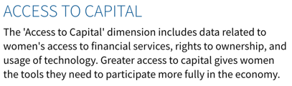
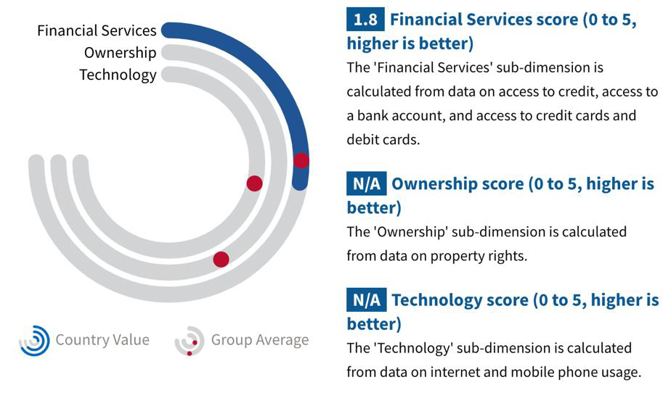

Source: USAID’s Women’s Economic Empowerment and Equality (WE3) Dashboard

ANNEX F: LEGAL AND INSTITUTIONAL FRAMEWORK
[Discuss relevant WEEGE legal and institutional policies that exist in the country or region. Use the following table as an example.]

TABLE 4. EXAMPLE SOLID WASTE MANAGEMENT AND RECYCLING LEGISLATION
COUNTRY | LEGAL INSTRUMENT | STATUS | RELATED ISSUES ADDRESSED
 |  |  | RECYCLING | GENDER | INFORMAL SECTOR
El Salvador | Environmental law (1998) | In force | Yes | Not mentioned | Not mentioned
 | National environmental strategy (2013) | In force | No data | No data | No data
 | Solid waste management improvement plan for El Salvador (2010) | In force | No data | No data | No data

[Add or subtract rows and columns for additional related issues as needed.]

ANNEX G: RELEVANT ORGANIZATIONS
[List government, private sector, and civil society organizations working on WEEGE that exist in the country or region. Use the following table as an example.]

TABLE 5. EXAMPLE RELEVANT ORGANIZATIONS
GOVERNMENTAL ENTITIES | LOCATION | WEBSITE
Economic commission of [region] | [Region] | [Link]
Forum of ministers of environment | [Region] | [Link]
Ministry of health | [Country] | [Link]
Federation of municipal districts | [Municipality] | [Link]
NON-GOVERNMENTAL ORGANIZATIONS AND ASSOCIATIONS | LOCATION | WEBSITE
Association to end violence against women | [Region] | [Link]
Women business association | [Country] | [Link]
National association of [sector employees] | [Country] | [Link]
PRIVATE-SECTOR COMPANIES | LOCATION | WEBSITE
[Local] company | [Country] | [Link]
[Multinational] company | [Country] | [Link]
Woman-owned small and medium enterprise | [Country] | [Link]

ANNEX H: RESOURCES
[List resources that will help the mission make progress on WEEGE. Use the following table as an example.]

TABLE 6. EXAMPLE RESOURCES
SECTOR RESOURCES | DESCRIPTION | WEBSITE
Engendering Utilities: Increasing Women’s Participation in the Power Sector through Human Resources Interventions: A Best Practices Framework | Provides practical examples of strategies for decreasing gender bias and increasing women’s participation and advancement in the male-dominated power sector. | https://pdf.usaid.gov/pdf_docs/PA00TC59.pdf
[Source] | [Summary] | [Link]
POLICY RECOMMENDATION RESOURCES | DESCRIPTION | WEBSITE
[Source] | [Summary] | [Link]
[Source] | [Summary] | [Link]
PRIVATE-SECTOR ENGAGEMENT RESOURCES | DESCRIPTION | WEBSITE
[Source] | [Summary] | [Link]
[Source] | [Summary] | [Link]

Miriam Webster Dictionary online: https://www.merriam-webster.com/dictionary/allyship
Reference also Dahlerup, D. (2006), The story of the theory of critical mass. Politics & Gender 2 (4): 511–522.
Landel, M. (2015), Gender balance and the link to performance. Available at https://www.mckinsey.com/featured-insights/leadership/gender-balance-and-the-link-to-performance
U.S. Department of State (2016), United States strategy to prevent and respond to gender-based violence globally. Available at https://www.state.gov/wp-content/uploads/2019/03/258703.pdf.
USAID (2015), Working with Men and Boys to End Violence Against Women and Girls: Approaches, Challenges, and Lessons. Available at https://www.usaid.gov/sites/default/files/Sector-5-SocialDev_MenandBoys.pdf.
USAID (2005). microNOTE #6 AMAP BDS Knowledge and Practice Task Order - Lexicon. Available at https://www.marketlinks.org/sites/default/files/resource/files/ML1778_mn_6_lexicon_03_05.pdf
This is not an official definition of USAID or any other organization but rather a practical working definition that provides sufficient clarity in pursuing USAID’s economic goals with regard to gender equality and female empowerment.

