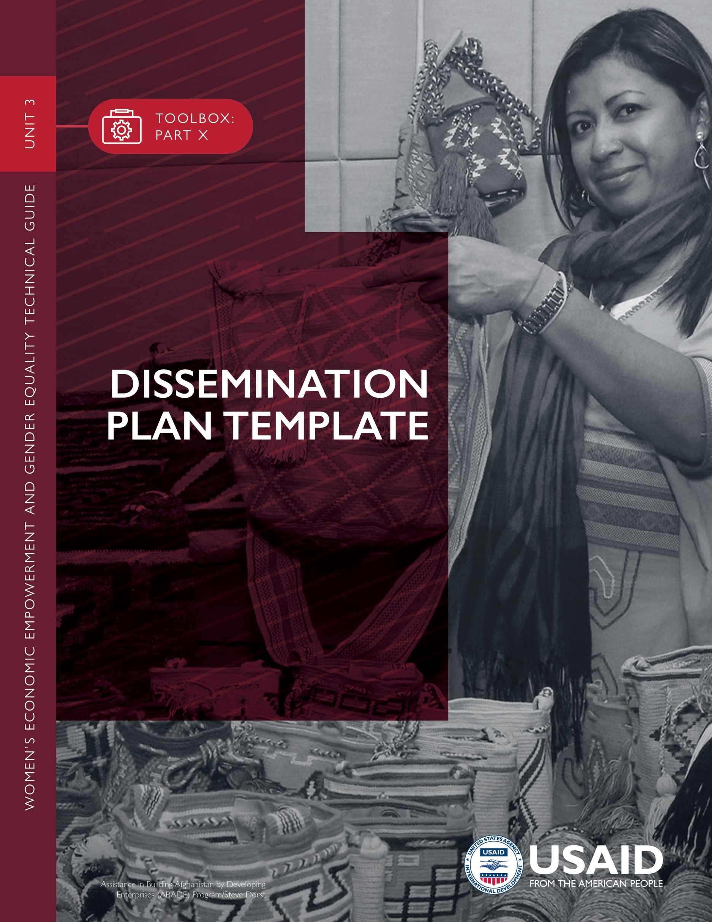

USAID and/or implementing partner(s) should begin initial planning for dissemination, if needed, at the early stages of a gender analysis. Incorporation of a women’s economic empowerment and gender equality (WEEGE) lens should include dissemination activities into the scope of work (SOW) for the gender analysis team. By articulating the dissemination plan in the SOW, the gender analysis team can budget
and plan for data collection and presenting results. The dissemination plan, however, may
be updated throughout the analysis based on new information and learning.

INSTRUCTIONS

STEP 1
Identify a broad group of stakeholders with input from USAID, technical specialists and implementing partners. Stakeholders are individuals or organizations that are likely to be affected by or interested in the analysis findings and could include: USAID technical officers, gender specialists, procurement specialists and leadership; private sector companies; government officials; advocacy organizations; and women’s associations.

STEP 2
For each identified stakeholder, determine the goal for dissemination. Is it to change policy? To influence sector strategies or activity design? To contribute to a learning agenda?

STEP 3
Identify appropriate communications tools for each dissemination goal. Communications tools are closely linked to the target audience and may include blogs, social media and emails, as well as formal reports, briefs and press releases. They also may include journal articles, videos, meetings, presentations, workshops, discussions panels and other in-country or Washington, DC-based events.

STEP 4
For each identified stakeholder group, consider what existing forums or channels may best reach it, taking into account: literacy levels; native language; access to the internet, cell phone, radio, television and other media sources; appropriate listservs, journals and websites; planned events and decision-making points; and resources available for design and editing. Think about possible dissemination partners—individuals, organizations or networks who may be helpful in disseminating information.

STEP 5
Identify responsible parties and a timeline for each dissemination activity.
Plan for follow-up surveys or feedback mechanisms to document the impact of the analysis and associated knowledge products, as needed. This material can include web and social media analytics.
STEP 6

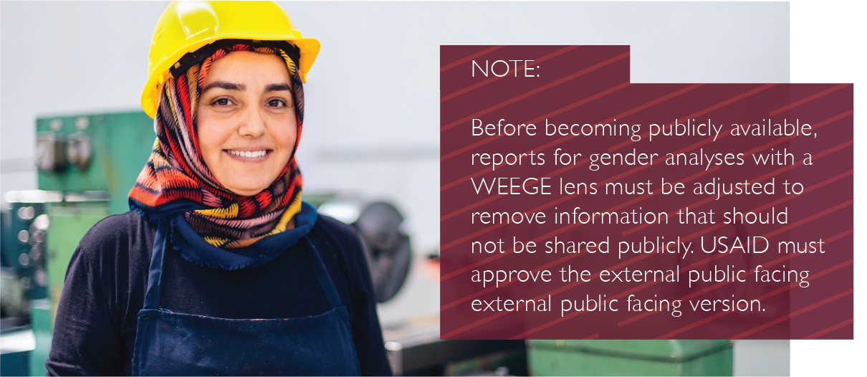
DISSEMINATION PLAN: COMPONENTS
ITEM | AUDIENCE | GOAL | TOOL/MEDIUM | FORUM | RESPONSIBLE PARTY | TIMING | FOLLOW UP
Gender Analysis with a WEEGE Lens Report | Identify stakeholders by asking, “Who is likely to be affected by the gender analysis with WEEGE lens and its results? Who is likely to be interested?” | Clarify the goal: Are we simply pushing out information? Intending to affect change? Contributing to the knowledge base? | These tools may include reports, briefs, presentations, blog posts, meetings, facilitated discussions, videos, journal articles, press releases, graphics and emails to listservs. | Are there existing networks or venues through which findings should be disseminated? Or will communications be distributed directly to target audiences? | Who is responsible? | Is there a deadline? | Did we achieve our goal? What was the result of the information sharing? Any observable outcomes?

